|  |
| --- |
| *Supplementary Information*  **PoPsicle: a flexible R Package for the preprocessing and quality control analysis of single cell RNA-seq data.**  Jimmy Caroli1,2, Andrea Grilli1, Francesco Grandi1, Martina Dori1, Oriana Romano1, Mattia Forcato1, and Silvio Bicciato1*  1 Department of Life Sciences, University of Modena and Reggio Emilia, Modena, Italy  2 Department of Drug Design and Pharmacology, University of Copenhagen, Copenhagen, Denmark |

|  |
| --- |
| **WORKFLOW** **DESCRIPTION**…………………………………………………………………………………... |
| Step 1: Input preparation and quality control ………………………………………………….......................... 2 |
| Step 2: Data filtering……………………………………………………………….………………………….. |
| Step 3: Doublets calculation ...……………………….…....……………………………………………….... |
| Step 4: Normalization ………………………………....……………………………………….……………… |
| Step 5: Regression……………………………………………………………………………………………...  Step 6: Clustering …………………...………………………………………………………..……………......  Step 7: Annotation……………………………………………………………………………………………… |
| **INSTALLATION AND USAGE**……………………………..…………………………………………………… |
| Installation...……………………………………………………………………………………..……………... |
| Dependencies……………………………………………………………………………………..……………... |
| Comparison with scCancer………………………………………………………………………..……………... |
| **REFERENCES**…………………………………………………………………………………………………… |

**WORKFLOW DESCRIPTION**

Here we present PoPsicle, a flexible R package designed for the pre-processing and analysis of single cell RNA-seq data. PoPsicle builds on the R package Seurat (v3.5) **(Stuart *et al.*, 2019)** as long as several other assessed packages (i.e. Scrublet for doublets discovery, SingleR for cell annotation, etc.. **(Wolock *et al.*, 2019; Aran *et al.*, 2019)**), integrating in its workflow most of the commonly performed procedures in scRNA-seq analyses. The main focus of this R package points towards quality controls, investigating several different data features. This approach is guided by the inner versatility of the tool, the generated plots for each inspected metric and the ability to tailor each parameter of the analysis thanks to specific built in functions. PoPsicle accepts data derived from both 10X and smart-seq sequencing protocols, and it has been designed to be able to investigate and analyse both human and mouse data.

The analysis pipeline of PoPsicle follows seven sequential steps, backed by seven dedicated functions: i) input preparation (PrePlots), ii) data filtering (FilterPlots), iii) doublets calculation (CalculateDoublets), iv) data normalization (Normalize), v) regression calculation (ApplyRegression), vi) cell clustering (CalculateCluster), and, vii) single cell data annotation (MakeAnnotation). Each of these steps will be discussed in depth in the following sections.

**Step 1: input preparation and quality controls (QCs)**

The first step in the PoPsicle workflow consists in the input data preparation and preliminary quality controls performance, callable via the function PrePlots. Both 10X and smart-seq sequencing data can be used as input in this preliminary preparation step: in the first case, a filtered feature barcode matrix must be provided, usually derived from a previous CellRanger processing. PoPsicle requires the path to the folder data as input for its preprocessing, rather than the single matrix file, for example:

sample_folder/outs

├── filtered_feature_bc_matrix

│ ├── barcodes.tsv.gz

│ ├── features.tsv.gz

│ └── matrix.mtx.gz

Conversely, when investigating smart-seq data a matrix should be set as the desired input for the calculation. No folder path is required in this case. Three main plots are generated in this first step: violin plotsallow user to explore data distribution regarding number of genes (nFeature_RNA), number of UMI (nCount_RNA), mitochondrial genes percentage (percent_mt), ribosomal genes percentage (percent_ribo) and dissociation genes percentage (percent_disso) (ref);

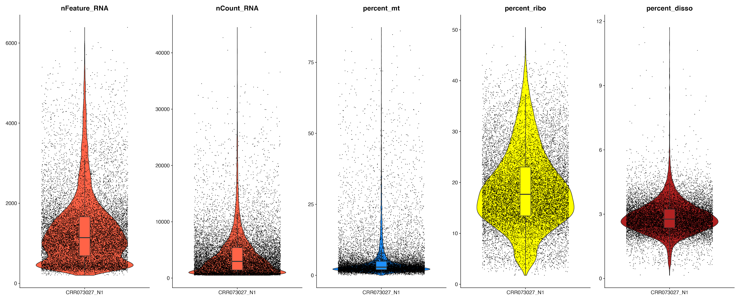

**Supplementary Figure 1**: Violin Plots generated by PoPsicle in the PrePlotsfunction. It is possible to investigate data distributions of (from left to right) number of Genes, number of UMI, mitochondrial genes percentage, ribosomal genes percentage and dissociation genes percentage.

Scatter plots enable the identification of data correlation between variables. The same parameters described in the violin plots section (i.e. number of genes, number of UMI, mitochondrial genes percentage, ribosomal genes percentage and dissociation genes percentage) are investigated using scatter plots, comparing two metrics in each different plot.

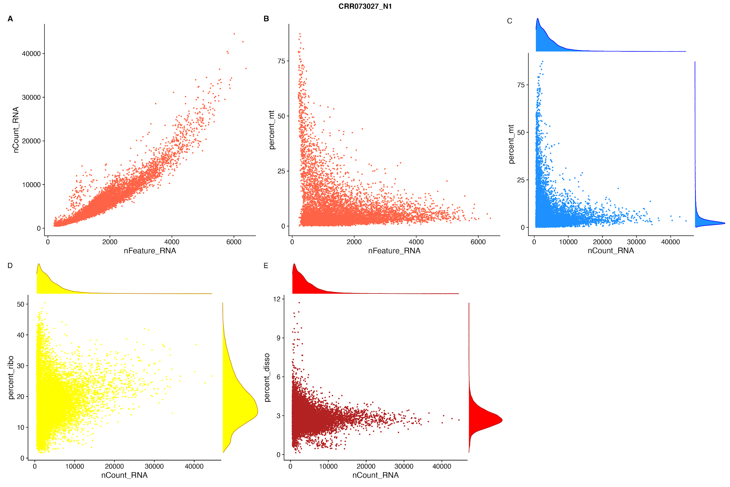

**Supplementary Figure 2:**Scatter Plots generated by PoPsicle in the PrePlotsfunction. Plot **A** shows positive correlation between number of genes and number of UMI, a common situation in scRNA-seq experiments. Plot **B** shows correlation between mitochondrial genes percentage and number of genes. Here we can observe cells characterized by low gene expression values and a large mitochondrial fraction. High rate of mitochondrial genes is often a marker of cell damage, implying that these cells are lysed or necrotic and must be removed from the dataset for further analysis. Plot **C** shows mitochondrial genes against the number of UMI, reinforcing previous considerations. Plot **D** shows ribosomal genes percentage; high percentage of ribosomal genes indicates damaged cells supposedly lysed or necrotic. Plot **E** shows dissociation genes percentage compared with the number of UMI per cell. A high ratio of dissociation genes can seriously affect the cell state, pointing towards stress induced cells. Moreover plots **C**, **D**, **E** show data distribution on their axes. Through these graphs a user can set his own thresholds to filter data accordingly.

Moreover, density plots are generated, based on the same variables previously mentioned.

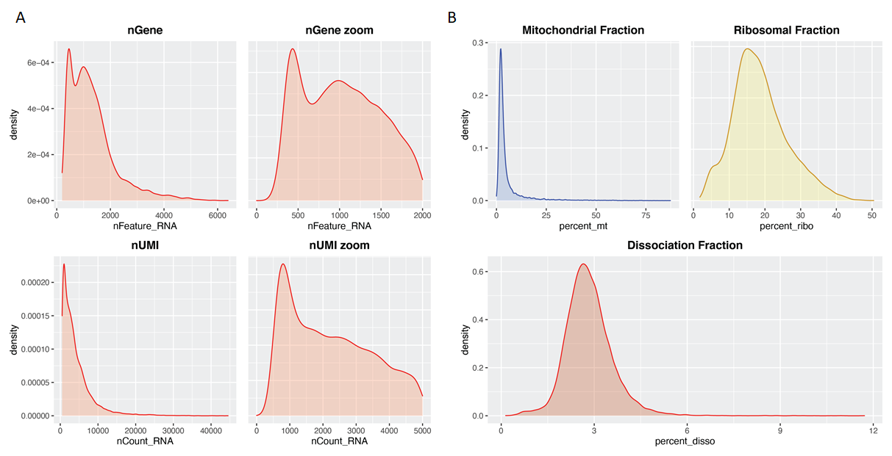

**Supplementary Figure 3:**Density plots generated by PoPsicle in the PrePlots function. Plot **A** shows distributions of genes and UMI, along with additional zoomed graphs providing deeper data inspection. Distributions may be multi-modal and minor peaks might be hidden by the main peaks. In these cases, setting correct thresholds is critical due to the risk of an erroneous exclusion of some cellular population characterized by a low gene expression (i.e. T Cells). Plot **B** shows distributions of mitochondrial genes percentage (in blue), ribosomal genes percentage (in yellow) and dissociation genes percentage (in red).

Furthermore, PoPsicle function PrePlotsalso accepts a list of genes, granting the ability to explore their expression through dedicated plots for each single gene of interest.

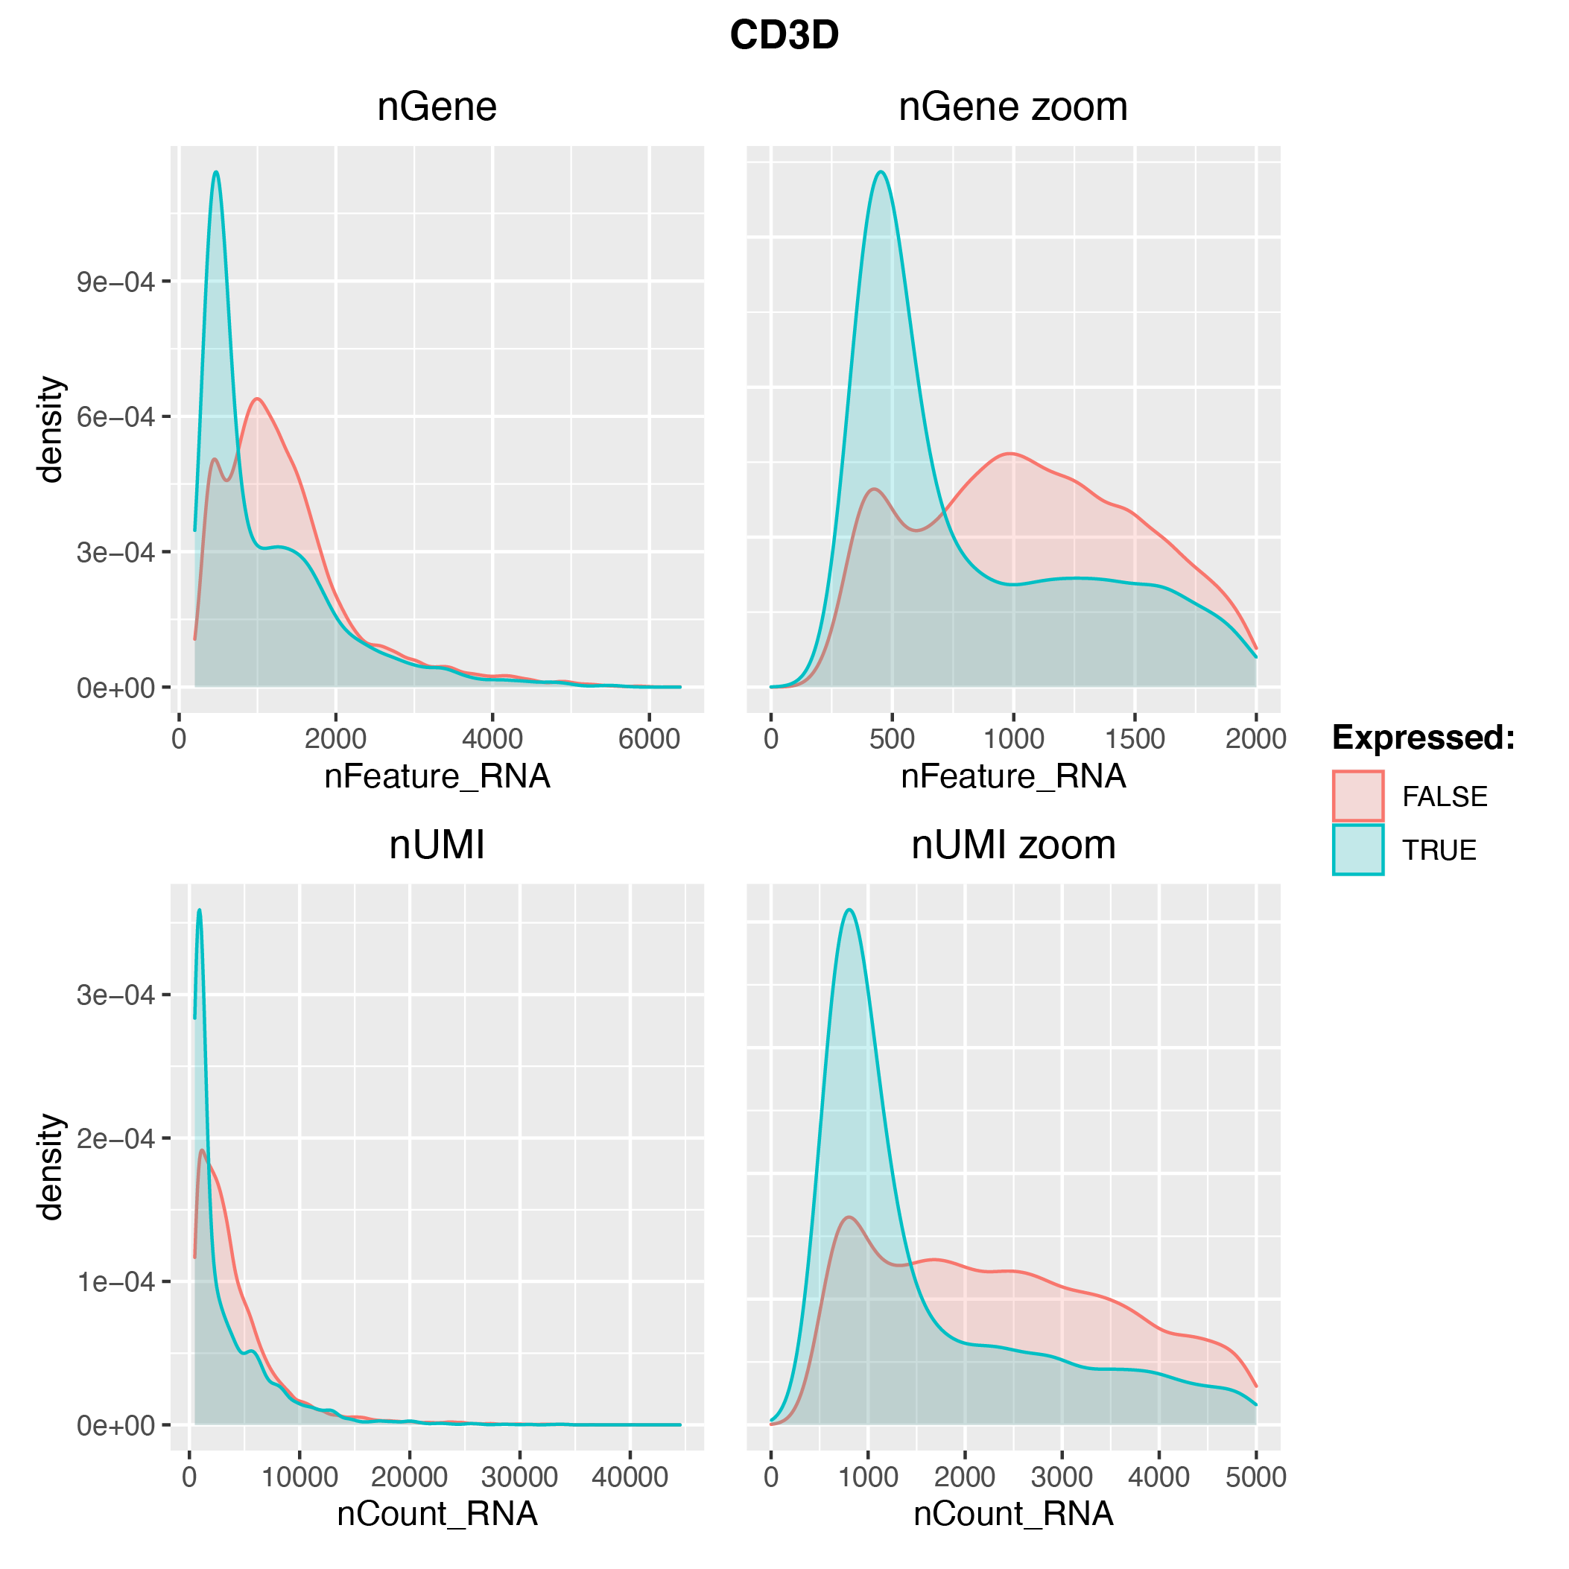

**Supplementary Figure 4:**Density plots for single gene of interest generated by PoPsicle in thePrePlotsfunction*.* In this case, plots show CD3D expression (blue), a known T Cell marker, compared to the expression values of other genes (red). These plots showcase an example in which the selected marker (CD3D) is highly expressed across the investigated cell panel, indicating a putative population of T cells.

Lastly, PoPsicle creates dedicated scatter plots for genes of interest provided by the user through an optional array. In these plots, variables visualized are: number of genes, number of UMI, mitochondrial genes percentage and counts.



**Supplementary figure 5:**Example of scatter plots for single gene of interest generated byPoPsicle in thePrePlots function*.* Using a user provided list of genes of interest, PrePlots creates eight graphs exploring expression values for each gene. Here we report results for the CD3D gene. In these graphs, cells expressing CD3D are represented in blue, while cells not expressing the gene are shown in red. Plot **A** shows the number of genes detected paired to the percentage of mitochondrial genes; in the title is reported the number of cells expressing the gene. Plot **B** is a zoom-in of the previous graph, showing a more detailed picture of the distribution. Plots **C** and **D** show only cells expressing the gene of interest. Similar to plots **A** and **C**, plots **E** and **F** show the number of UMI detected paired to the percentage of mitochondrial genes. Plots **G** and **H** show counts for the gene of interest in each cell. In this example, CD3D is more expressed in cells characterized by a low gene expression, confirming that these can be T cells. T cells or other interesting populations can be filtered out due to inappropriate cut-offs. Plot **H** is a zoomed version of plot **G**. 

Here we report the default settings of PrePlots as described in the dedicated vignette:

PrePlots(sample, input_data, genelist, percentage=0.1, gene_filter=200, cellranger=TRUE, input_matrix=NULL, organism="human", out_folder=getwd())

Additional PrePlots parameters are listed and discussed below:

percentage indicates the percentage of cells that should show expression of a gene for it to be considered in the analysis. Default is 0.1.   
gene_filter defines the minimum number of expressed genes in a cell for it to be included in the analysis. Default 200.   
cellranger indicates if data has been generated via CellRanger. Default is TRUE.   
input_matrix is used when the input data has not been generated via Cellranger. Default is NULL.  
organism indicates the investigated organism. Default is human, can be mouse.  
out_folder defines the output folder in which will be saved the results. Default is the current working directory, creating a folder named “02.QC_Plots”.

**Step 2: Data filtering**

The second step in the PoPsicle workflow performs data filtering, and is addressed by the function FilterPlots. Given the extensive quality controls analysis conducted in the PrePlots function, users can define appropriate thresholds, applying specific data filtering throughout the FilterPlots function. In this step, cells considered unsuitable for further analysis are discarded, returning a newly generated Seurat object. Filters that can be defined in this step are: low and high threshold for gene number (respectively, G_RNA_low and G_RNA_hi), lower and upper threshold for UMI number (U_RNA_low and U_RNA_hi) and upper thresholds for mitochondrial, ribosomal and dissociation genes percentage (percent_mt_hi, percent_ribo_hi and percent_ribo_hi). Once thresholds are applied, *FilterPlots* generates summary graphs showing the final distributions and correlations of the data.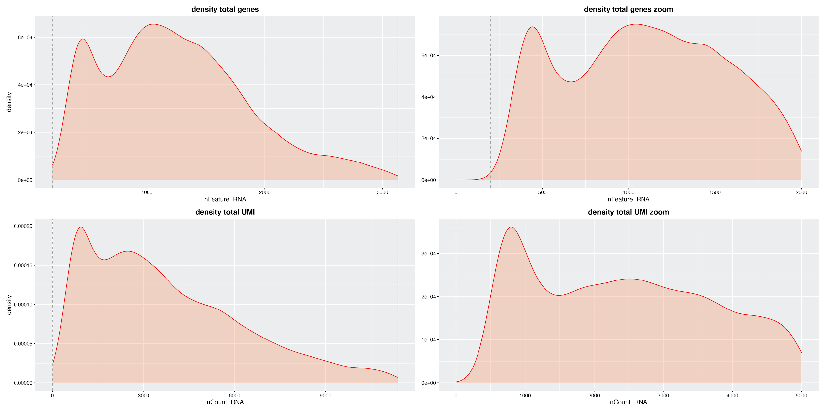

**Supplementary Figure 6*:*** Final density plots generated byPoPsicle in theFilterPlotsfunction. Plots show data distributions in **S3A** filtered according to the user defined thresholds. Cut-offs are visible as dashed grey lines. 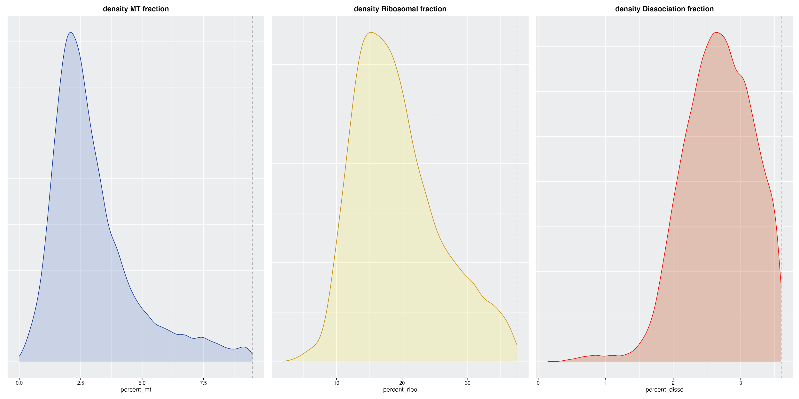

**Supplementary Figure 7:** Final scatter plots generated byPoPsicle in theFilterPlots function. Plots show data correlation in **S2** filtered according to user defined thresholds. Cut-offs are visible as dashed grey lines. 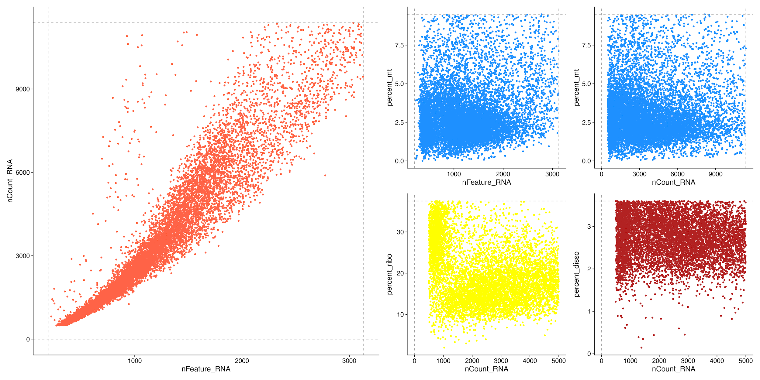

Here we report the default settings of FilterPlots as described in the dedicated vignette:

FilterPlots(UMI, G_RNA_low = 0, G_RNA_hi = Inf, U_RNA_low = 0, U_RNA_hi = Inf, percent_mt_hi = 100, percent_ribo_hi = 100, percent_ribo_hi = 100, out_folder=getwd())

Additional FilterPlots parameters are listed and discussed below:

UMI defines the input Seurat object to be analyzed.  
G_RNA_low defines the minimum number of genes detected in each cell. Default is 0.  
G_RNA_hi defines the maximum number of genes detected in each cell. Default is Inf as infinite, meaning no top value is set.  
U_RNA_low defines the minimum number of molecules detected within a cell. Default is 0.  
U_RNA_hi defines the minimum number of molecules detected within a cell. Default is Inf as infinite, meaning no top value is set.  
percent_mt defines the maximum percentage of mitochondrial genes tolerated. Default is 100.  
percent_ribo defines the maximum percentage of ribosomal genes. Default is 100.  
percent_disso defines the maximum percentage of dissociation genes. Default is 100.  
out_folder defines the output folder in which results will be saved. Default is the current working directory, generating a folder named “02.QC_Plots”.

**Step 3: doublets calculation**

The third step in the PoPsicle workflow is dedicated to doublet calculation and removal, through the function CalculateDoublets. Doublets are defined as groups of cells captured and barcoded with the same "unique" barcode, leading to inaccurate gene expression values for the detected “cell”. Thus, these erroneous data points should be promptly identified and removed from the pool of investigated cell data, as a measure of quality control of the analyzed sample. CalculateDoublets function is an R transposition of the python module Scrublet by Guo *et al.,* implemented based on the code provided by Chengxian Qiu at <https://rdrr.io/github/ChengxiangQiu/rscrublet/> and further adapted to generate more insightful plots. Once identified, doublets are removed and a cleaned Seurat object is returned. 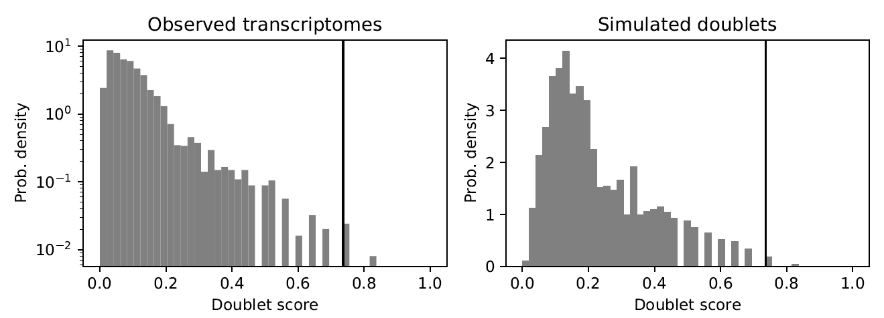

**Supplementary Figure 8.** Doublet score histograms generated by PoPsicle in theCalculateDoublets function**.** Observed (left) and simulated (right) doublets scores distributions are shown. Simulated doublets graph is typically bimodal. To divide doublets from singlets a threshold on doublet score must be set, ideally at the minimum between the two modes. Based on simulated doublets score a threshold for observed transcriptomes is automatically identified (in black). This threshold can be manually modified via the dbs_thr parameter.

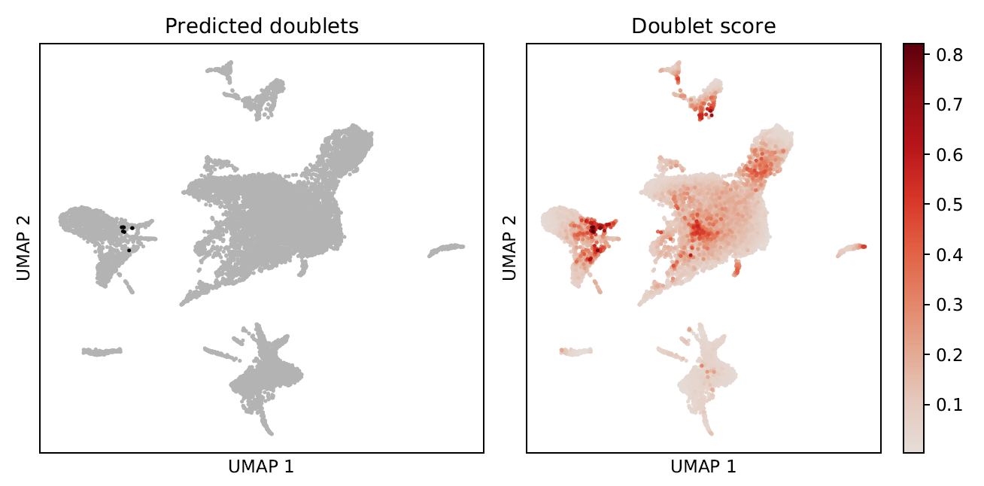

**Supplementary Figure 9.** Doublet predictions UMAP graphs generated by PoPsicle in the CalculateDoublets function. Each point corresponds to a cell. In the *Predicted doublets* graph, cells are coloured in black if predicted as doublets, grey as singlets. In the *Doublet score* graph cells are coloured accordingly to their score values (scale of reds).

Here we report the default settings of CalculateDoublets as described in the dedicated vignette:

CalculateDoublets(UMI, dbs_thr='none', dbs_remove=TRUE, out_folder=getwd())

Additional CalculateDoublets parameters are listed and discussed below:

UMI Input Seurat object.   
dbs_thr indicates doublet score threshold. Default is auto-calculated.   
dbs_remove indicates if, once identified, doublets are removed. Default is TRUE.   
out_folder defines the output folder in which results will be saved. Default is the current working directory, creating two files named “02d_doublets_real_and_simulated” and “02d_doublets_UMAP” stored in “02.QC_Plots” folder.

**Step 4: data normalization**

After doublet calculation and removal from the investigated pool, data should be normalized to be further processed. This can be performed via the function Normalize within the PoPsicle pipeline. Normalization process is performed via the function NormalizeData from the Seurat package, setting the normalization method to LogNormalize. Two different plots are generated in this step, showing the total gene expression values before and after the normalization process, and a plot showing the top ten most variable genes across the investigated sample.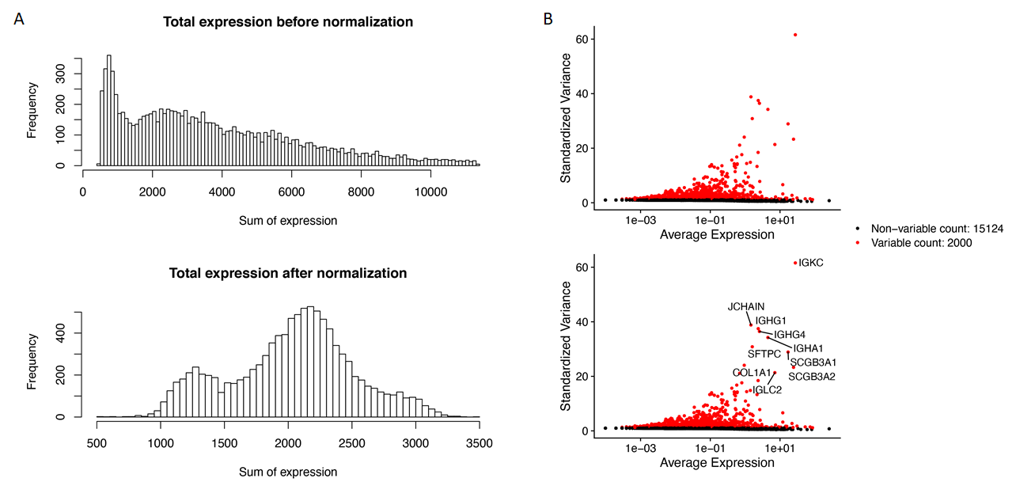

**Supplementary Figure 10.** Normalization and highly variable genes graphs generated by PoPsicle in the Normalize function. Plot **A** shows data distributions before (top) and after (bottom) normalization. Plot **B** shows in red high variable genes. The top ten most variable genes names (bottom) are visualized. The number of highly variable genes investigated can be modified through variable_genes parameter (default is 2000).

Here we report the default settings of Normalize as described in the dedicated vignette:

Normalize(UMI, variable_genes=2000, out_folder=getwd())

Additional Normalize parameters are listed and discussed below:

UMI defines the input Seurat object to be analyzed.  
variable_genes defines the number of highly variable genes investigated after normalization. Default is 2000.  
out_folder defines the output folder in which results will be saved. Default is the current working directory, generating a subfolder named “03.PreProcessing”.

**Step 5: regression calculation**

Step five is designed to perform regression analysis on different variables available, providing the user a higher grade of investigation and tailoring the analysis on the sample. This step is carried out calling the ApplyRegression function. Using the Seurat package, principal component analysis (PCA) is performed on the normalized data, along TSNE and UMAP calculations on all genes. PCA is performed using a standard number of 20 principal components, to provide a preliminary investigation. After this preliminary step, regression is calculated on the user input variables, and plots are stored in a different pdf file for comparison with the unregressed plot.

Regression can be performed on all Seurat object metadata fields. By default, no parameter is indicated on which to perform the regression. Available options are: number of genes, number of UMIs, percentage of mitochondrial genes, percentage of ribosomal genes and percentage of dissociation genes. Moreover, PoPsicle function CCScore (based on the Seurat package CellCycleScoring function) can estimate the cell cycle effect, providing new variables regarding the cell cycle to be regressed on, namely S.Score and G2M.Score. For each combination of variables selected for the regression, ApplyRegression creates a dedicated folder inside "03.PreProcessing" in which corresponding results are saved. Folders are names based on the starting letter of the variables used for the regression calculation.





**Supplementary Figure 11.** UMAP graphs generated by PoPsicle in the ApplyRegression function before (**A**) and after (**B**) regression. Plot **A** shows data distributions according to different variables: number of UMI (top-left), number of genes (top-right), mitochondrial genes percentage (bottom-left) and cell cycle phase (bottom-right) before regression. Plot **B** shows the same graphs after regression performed on the number of UMI (nCount_RNA) and on the percentage of mitochondrial genes (percent_mt).

Moreover, users can select to perform a deeper exploration of the principal components through dedicated plots using the variable explore_PC. By using this feature, heatmap, jackstraw and elbow plots showing information about the investigated principal components will be generated and stored in the dedicated output folder. These graphs will provide important insights for the identification of the most accurate number of principal components to use for further analysis.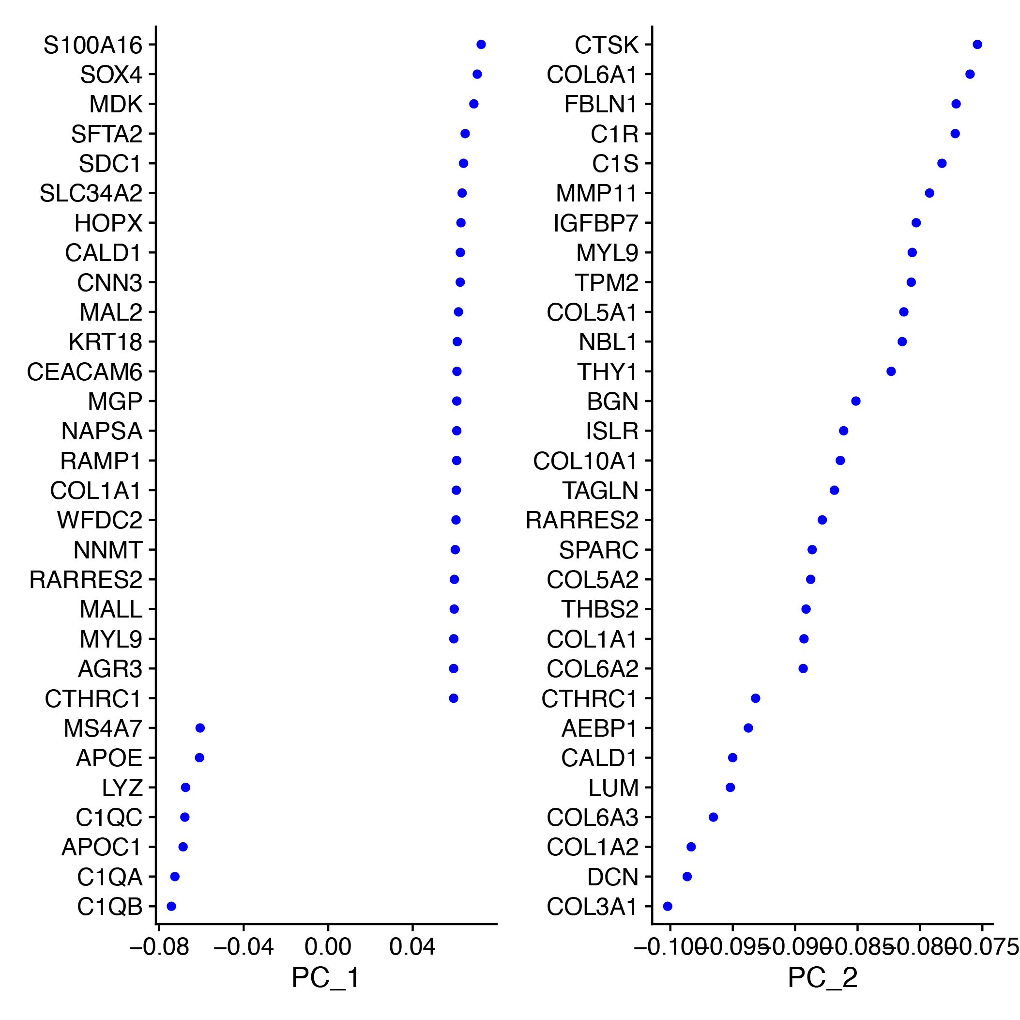

**Supplementary Figure 12.** Graphs for PC exploration generated by PoPsicle in the ApplyRegression function. This plot visualizes top genes associated with each principal component. Visualize the PCA “loadings.” Each “component” identified by PCA is a linear combination, or weighted sum, of the genes in the data set. Here, the “loadings” represent the weights of the genes in any given component. These plots tell you which genes contribute most to each component:

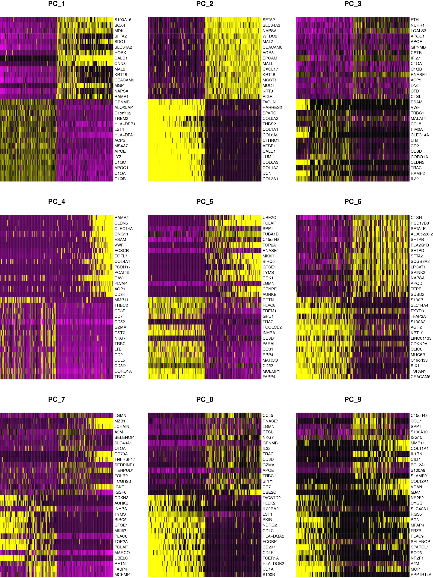

**Supplementary Figure 13.** Heatmaps for PCs exploration generated by PoPsicle in the ApplyRegression function. A heatmap for each PC is shown summarizing the expression of the most highly weighted genes in each principal component. In each heatmap, both cells (columns) and features (rows) are ordered according to their PCA scores(roughly speaking the cell scores are the eigenvector values, and the gene score is the linear combination of the cell score and the cell counts). A subset of cells on both “extreme” ends of the spectrum is displayed. Heatmap showing a noisy distribution of signal indicates principal components unable to correctly segregate information, whereas heatmaps showing a clean distribution of signal (such as PC2) indicate principal components able to provide insightful information for further analyses. These are plots of PCA weightings for the most highly and lowly weighted genes, shown against the set of cells which are most highly influenced by the PC. The idea is that as long as we’re seeing clear structure in one of these plots then we’re still adding potentially useful information to the analysis.

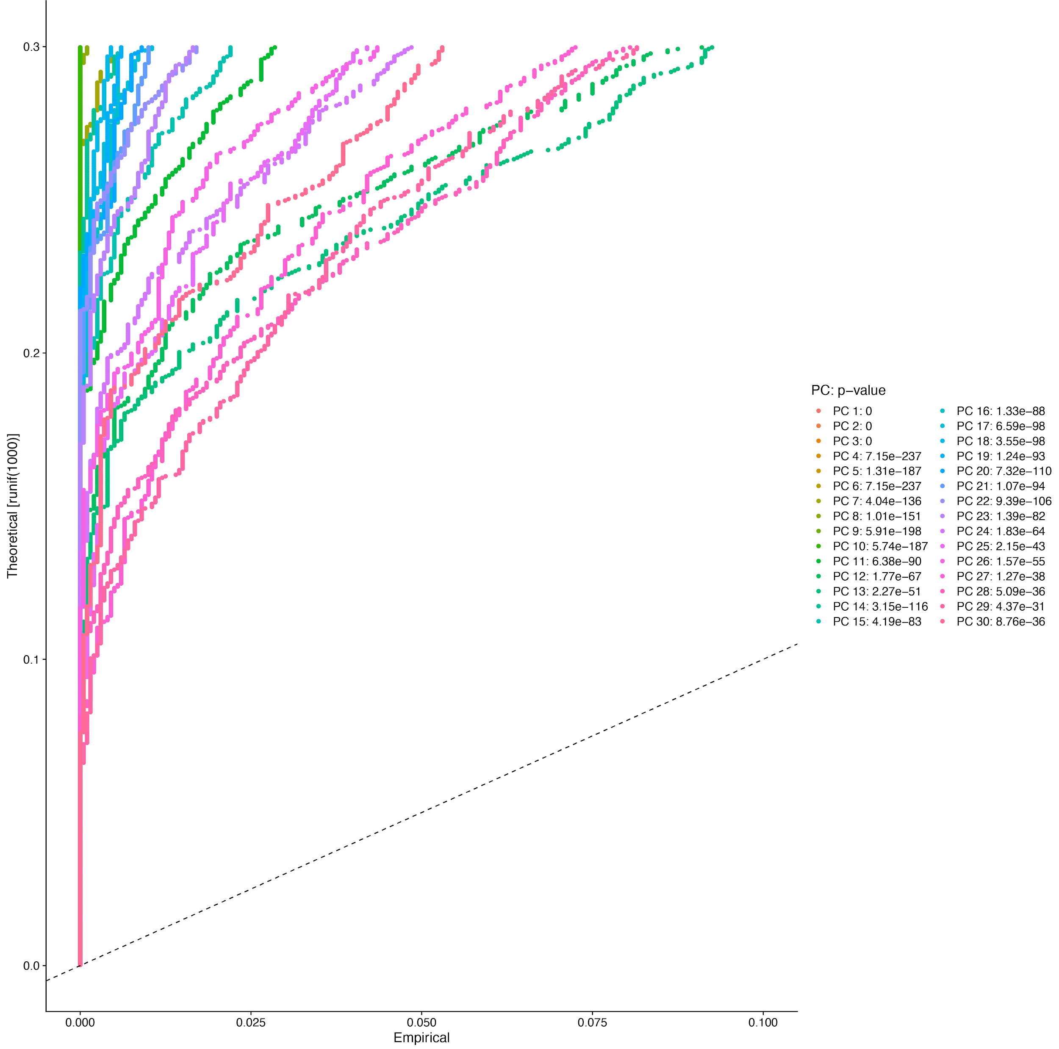

**Supplementary Figure 14.** Graphs for PC exploration generated by PoPsicle in the ApplyRegression function. This graph, called Jackstraw plot, shows the distribution of p-values for each PC with a uniform distribution (dashed line). PCs considered as significant have a strong enrichment of features with low p-values, so a solid curve above the dashed line. All PCs that do not have strong inflections in their curve are considered significant.

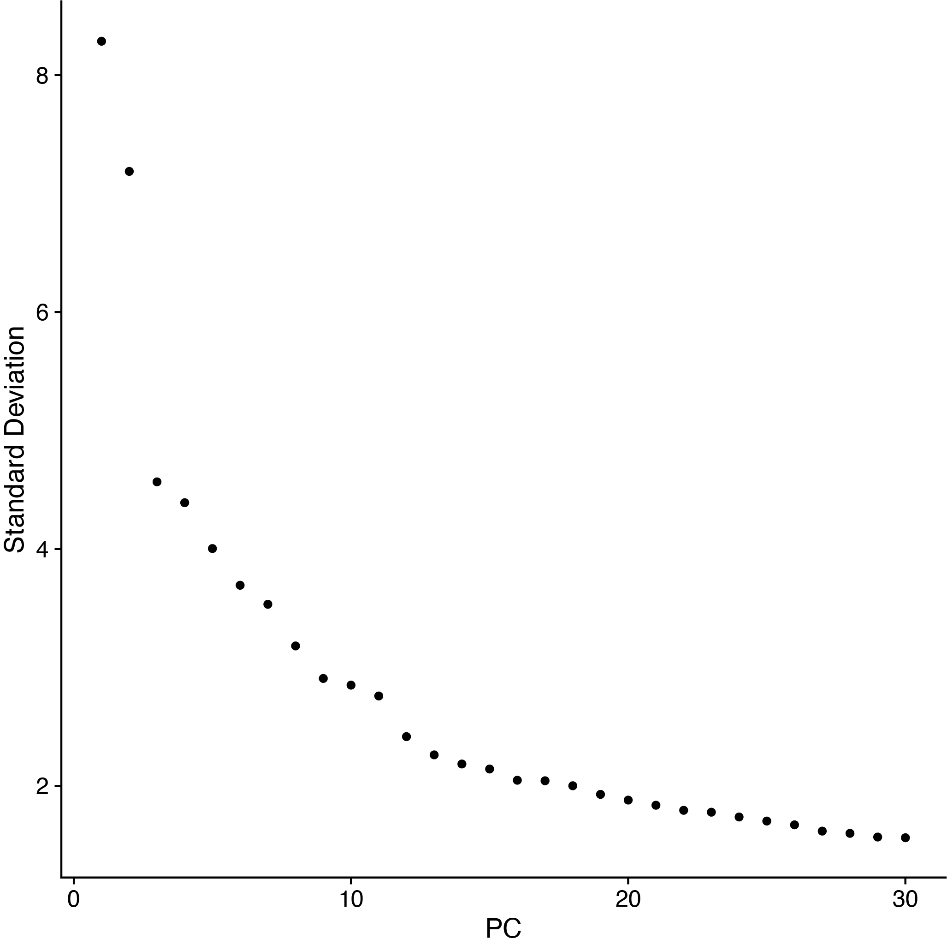

**Supplementary Figure 15.** Graphs for PC exploration generated by PoPsicle in the ApplyRegression function. This graph, named Elbow plot, displays the standard deviations of the principal components. This allows the identification of a flex in the graph that often corresponds to the significant dimensions that should be considered for downstream analysis. In this example, 14 PCs should be considered.

Here we report the default settings of ApplyRegression as described in the dedicated vignette:

ApplyRegression(UMI, variables='none', explore_PC=FALSE, out_folder=getwd())

Additional ApplyRegression parameters are listed and discussed below:

UMI Input Seurat Object  
variables requires a list (or single digit) of variables to be regressed on. Available variables can be: nFeature_RNA, nCount_RNA, percent_mt, percent_ribo, percent_disso, S.Score, G2M.Score. Default is 'none' as to not perform any regression  
explore_PC variable that defines if additional investigations on the principal component should be performed (when TRUE). Generates graphs described in Supplementary Figure 12. Default is FALSE.  
out_folder defines the output folder in which plots will be saved. Default is the current working directory, generating a subfolder named “03.PreProcessing”.

**Step 6: cell clustering**

The next step in the PoPsicle workflow is designed to perform clustering of the analyzed cells. Clustering calculation is performed via the function CalculateCluster, which is based mainly on the Seurat module. In this step a list of immune markers coupled with their cell populations is provided by default, but users are free to submit a custom one. Given this immune markers list PoPsicle performs data scaling and clustering, using the function FindClusters from Seurat. Clustering plots are generated for UMAP and TSNE by default, while PCA has to be set as TRUE by the user through a dedicated input variable. Lastly, PoPsicle calculates differentially expressed features, providing a set of eight different plots showing immune markers across each cluster (violin plot for top and all immune markers, UMAP, TSNE, heatmap and dotplot), along a tree showing correlation between the retrieved clusters.

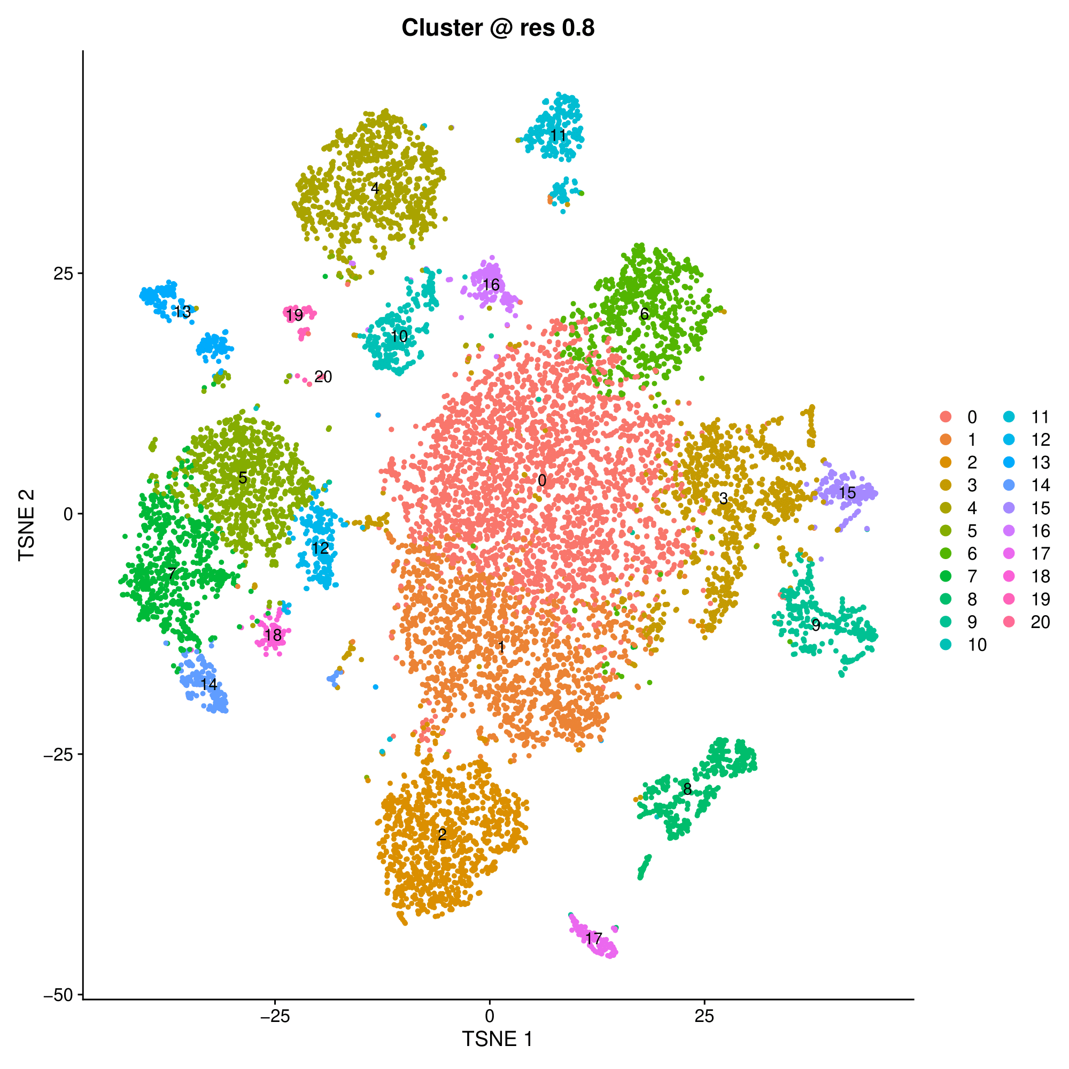

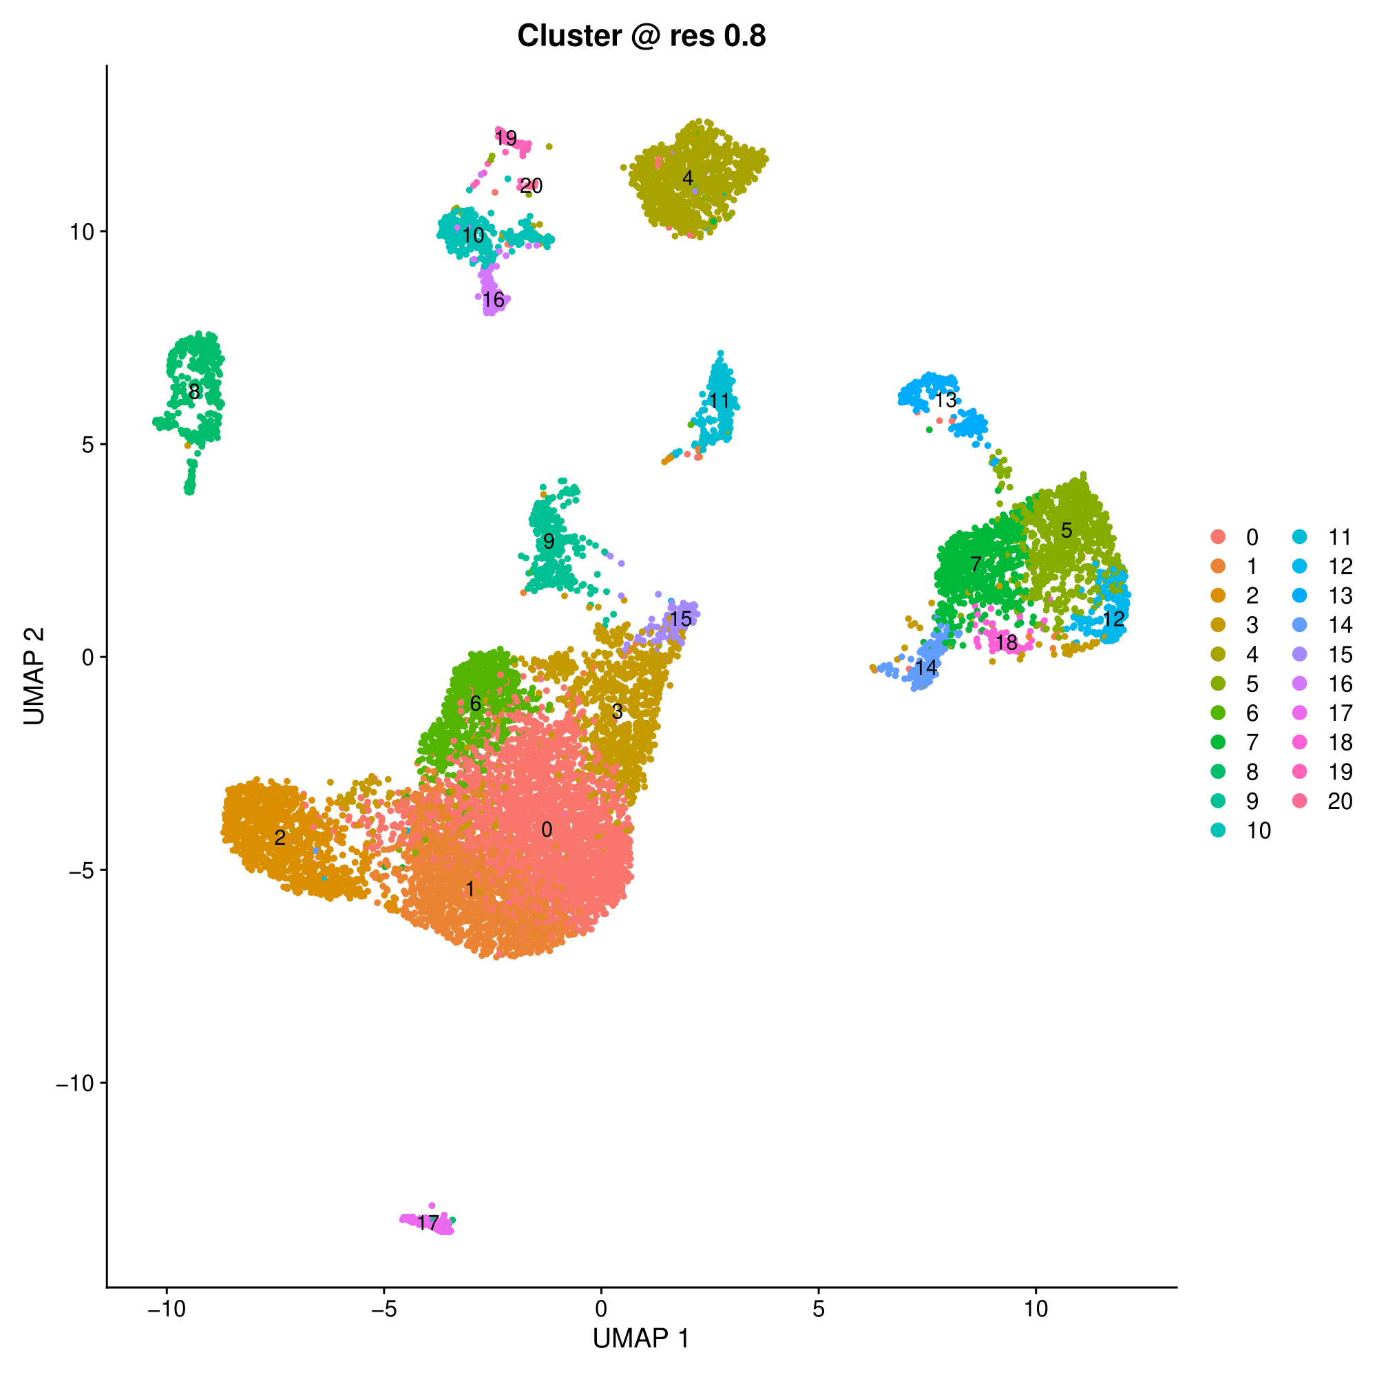

**Supplementary Figure 16.** Clustering dimensionality reduction graphs generated by PoPsicle in the CalculateCluster function. Examples of tSNE (top) and UMAP (bottom) generated by PoPsicle using 30 PCs: 21 different clusters were identified and colored, as reported in the legend. PCA clustering plots can also be provided if specified when calling the function.

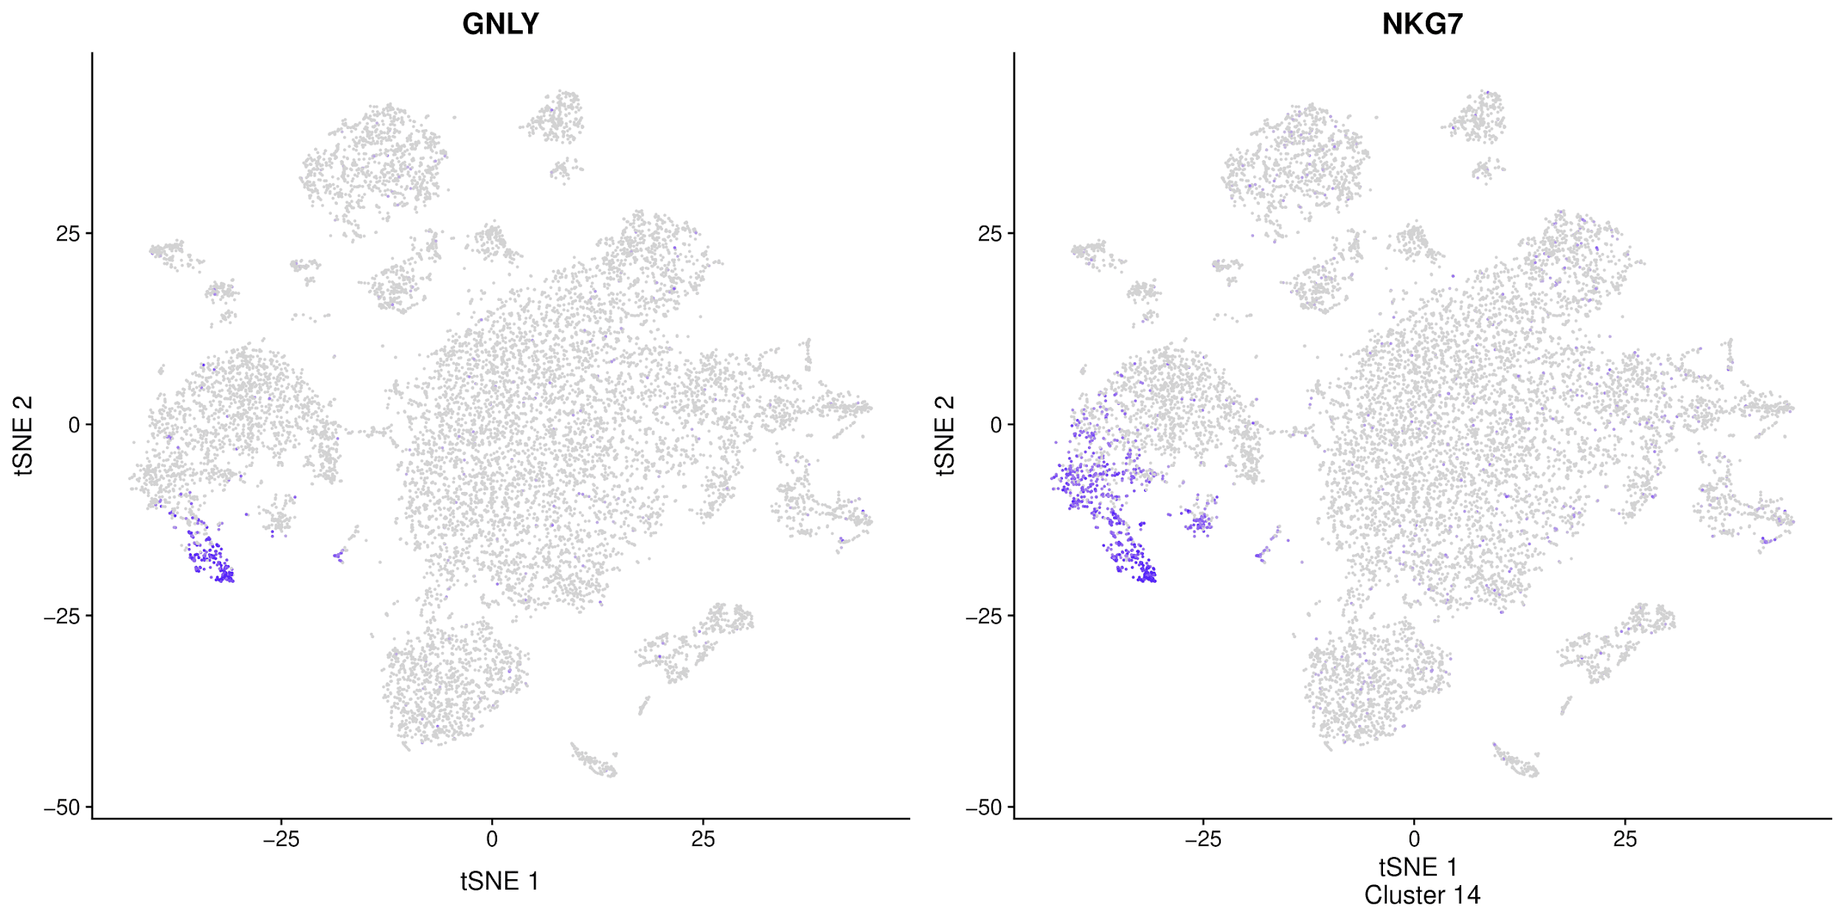

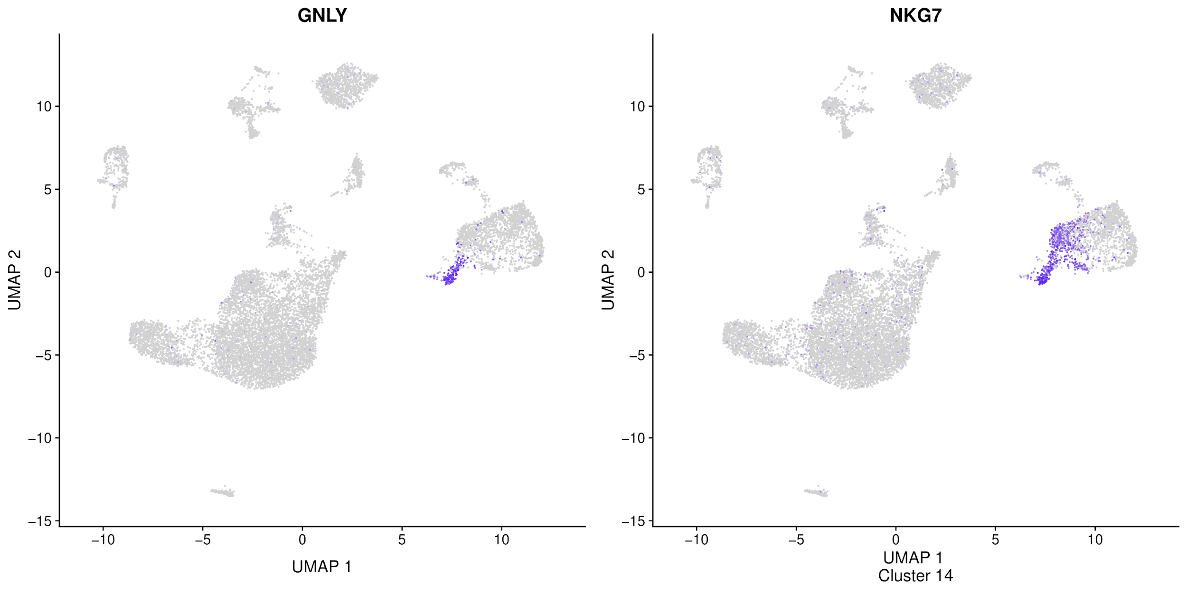**Supplementary Figure 17.** Top marker genes plots generated by PoPsicle in the CalculateCluster function. For each cluster, the expression of the top two markers is visualized through tSNE (top), UMAP (bottom) and Violin plot (Supplementary Figure 15). In these examples, the expression of the top markers of cluster 14 (NKG7 and GNLY) is reported. Comparing the expression of these genes with the previous clustering tSNE and UMAP (Supplementary Figure 13), it is possible to observe that only cluster 14 shows the expression of both genes. As these genes are putative markers of NK cells, it is highly probable that cluster 14 defines an NK cells population. Through visual inspection of these graphs and violin plots (shown below), it is possible to infer a potential annotation of each of the retrieved clusters.

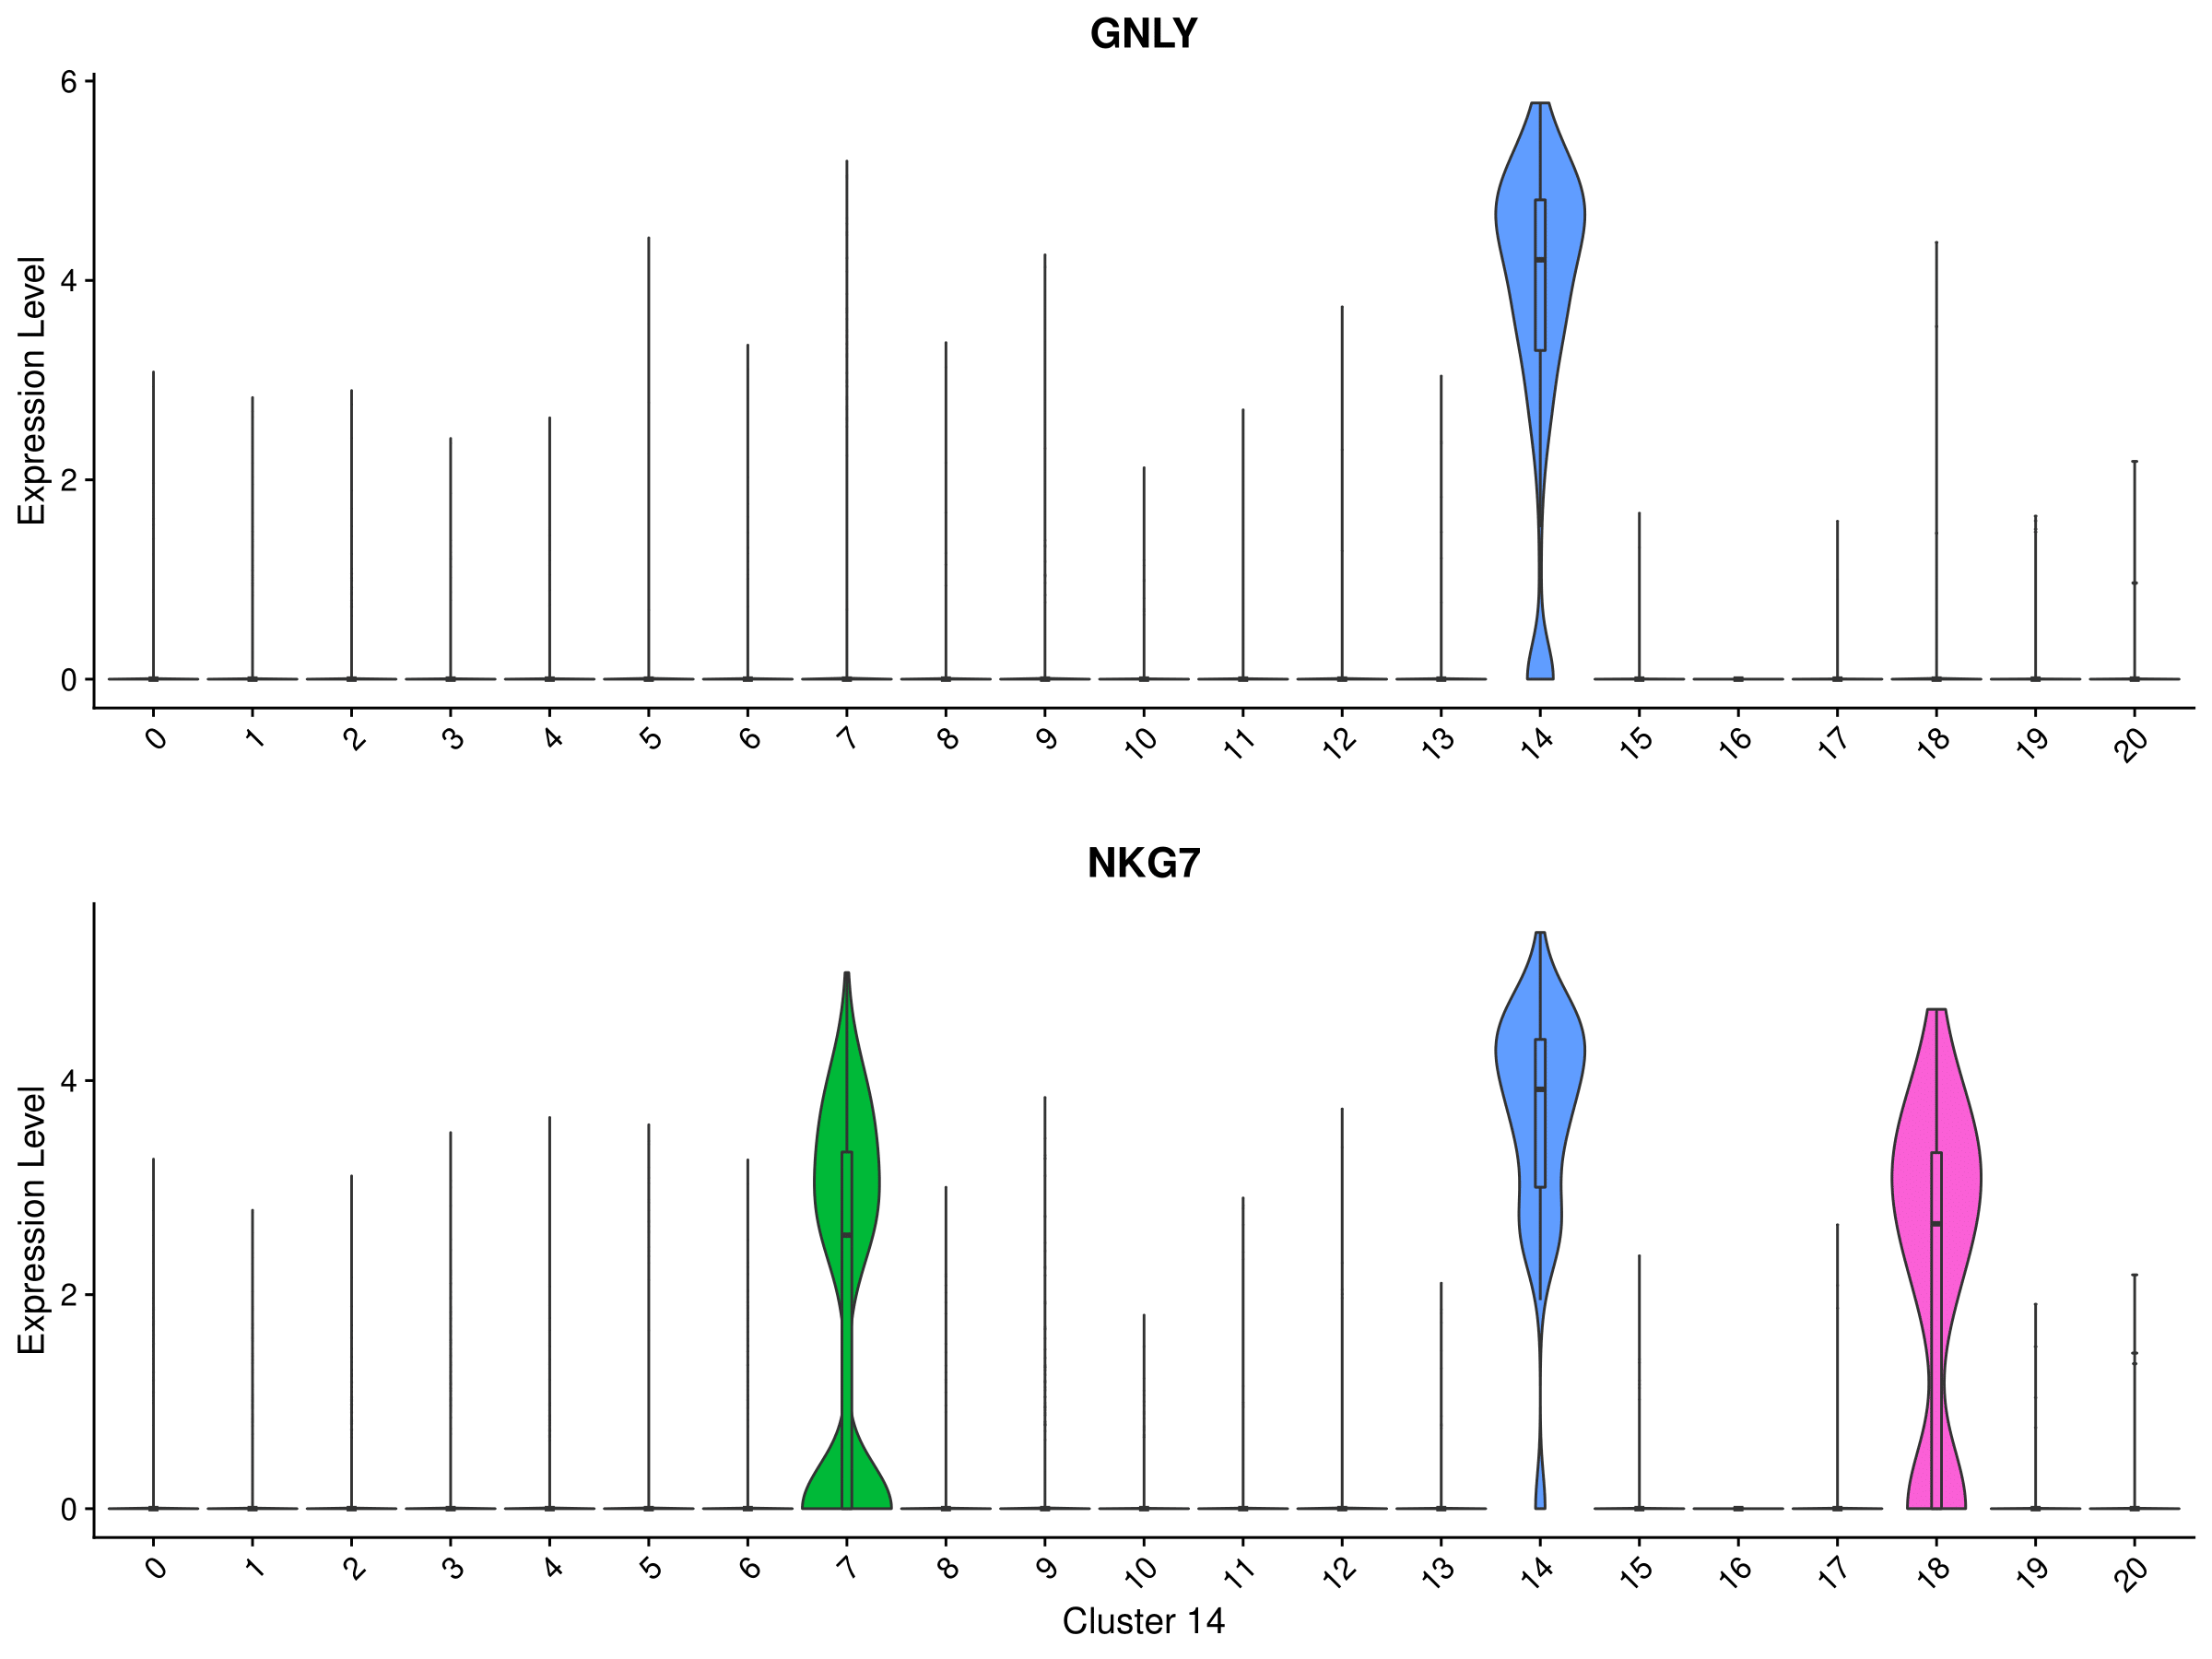

**Supplementary Figure 18.** Violin plots generated by PoPsicle in the CalculateCluster function showing the top two most expressed marker genes for each cluster. For sake of consistency and comparison, the expression of the top markers of cluster 14 (NKG7 and GNLY genes) is reported. As previously stated, high expression values of both genes are found only in cluster 14, even though NKG7 show lower expression in clusters 7 and 18.

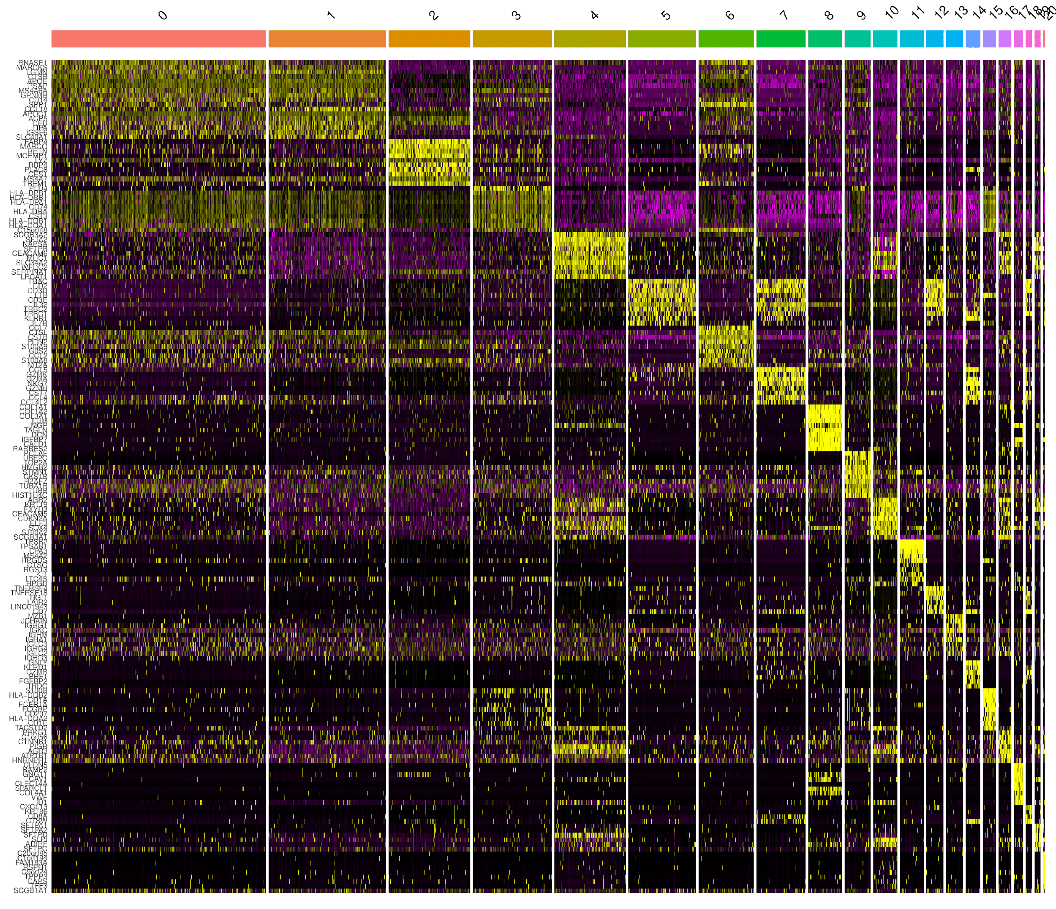

**Supplementary Figure 19.** Heatmap generated by PoPsicle in the CalculateCluster function, reporting expression values of the top 10 markers of each defined cluster. Heatmap shows that the specific panel of marker genes of each cluster is highly expressed in its relative cluster (high expression shown in yellow), strengthening clustering performances. Based on these cluster markers, users can perform identification of putative populations or cellular states within the investigated sample.

**Supplementary Figure 20.** Cluster tree generated by PoPsicle in the CalculateCluster function, showing similarity distances between identified clusters. 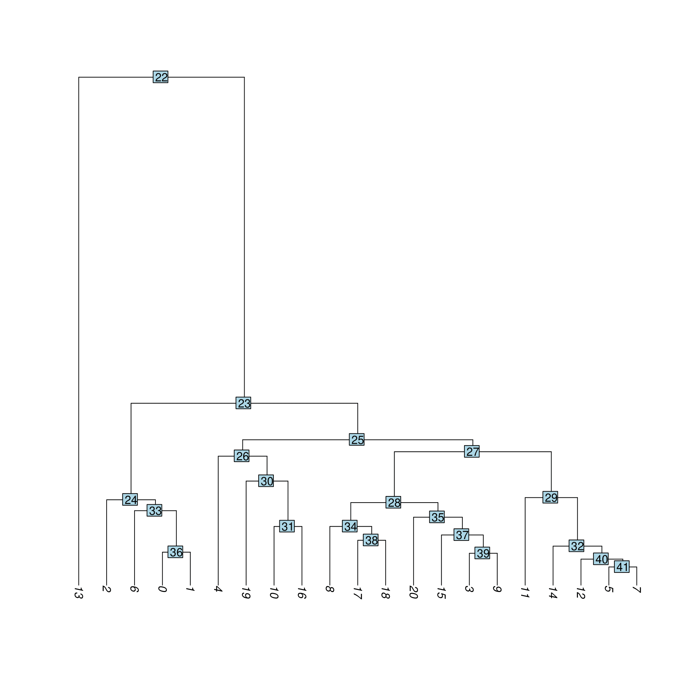

**Supplementary Figure 21.** Dotplotgenerated by PoPsicle in the CalculateCluster function. The x axis lists the immune markers (PoPsicle default list), while the y axis reports the retrieved clusters. Each dot reports the percentage of cells expressing that specific marker gene in that cluster. Average expression is standardized by column, meaning that it is possible to compare a marker gene expression across clusters. 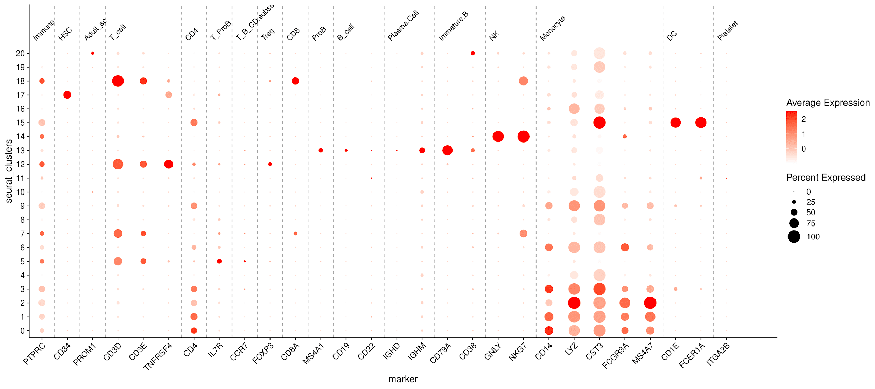

Here we report the default settings of CalculateCluster as described in the dedicated vignette:

CalculateCluster(UMI, dimpca, organism, immune.markers='none', PCA=TRUE, cluster_res=0.8, out_folder=getwd())

Additional CalculateCluster parameters are listed and discussed below:

UMI Input Seurat object  
dimpca defines the number of principal components to be considered for the analysis.  
organism indicates the organism used for the analysis. Default is set to “human”, but can be “mouse”. The organism choice also defines the immune marker list for the subsequent analysis.  
immune.markers by default, it is a list of immune markers already defined within PoPsicle, which may vary based on the selected organism. A custom gene list can be set as input if it complies with the input structure.  
PCA when TRUE Principal Components Analysis (PCA) is calculated and associated graphs are generated. Default is set to TRUE  
cluster_res defines cluster resolution. Default is set to 0.8.   
out_folder defines the output folder in which results will be saved. Default is the current working directory, creating a subfolder named “04.Clustering”.

**Step 7: single cell data annotation**

The last step of PoPsicle handles single cell annotation. Different packages are invoked in this section, depending on the organism investigated: SingleR is used to annotate data derived from human samples, using both the human primary cell atlas data (HPCA) and the blueprint Encode data (BpEn), while scMCA provides information when mouse samples are analyzed, based on the ImmGen data. As described in step six, a default list of immune markers is used throughout this calculation, and users are free to provide a custom one for their own analysis. Users can perform cells and clusters annotation calling the MakeAnnotation function and specifying the reference organism. Using SingleR, for each reference, both single cell and cluster annotation graphs (tSNE and UMAP) will be generated. Moreover, PoPsicle provides the possibility to further explore single populations in the generated dimensionality reduction graphs. Lastly, for each reference a dotplot with related labels is created.

S**upplementary Figure 22.** tSNE single cell annotation graph generated by PoPsicle in the MakeAnnotation function. Clustering tSNE is reported (top); on the same embeddings, cells are coloured by their annotation assigned through single cell mode with SingleR (bottom). As indicated in annotation graph legend, each colour corresponds to a cellular type (according to Blueprint Encode annotation). In this case the larger population is the macrophages one (blue) comprising clusters 0,1,2,3,6,8,9,11,15,16.

**Supplementary Figure 23.** tSNEcluster annotation graph generated by PoPsicle in the MakeAnnotation function. Clustering tSNE is reported (top); on the same embeddings, clusters are coloured by their annotation assigned through cluster mode with SingleR (bottom). Each cluster is coloured with a different colour and, on each one, cluster number and annotation are shown (according to Blueprint Encode annotation). As described in Supplementary Figure 22, clusters 0,1,2,3,4,6,8,9,11,15,16 all point towards the same Macrophages class.

**Supplementary Figure 24.** UMAP single cell annotation graph generated by PoPsicle in the MakeAnnotation function. Clustering UMAP is reported (top); on the same embeddings, cells are coloured by their annotation assigned through single cell mode with SingleR (bottom). As indicated in annotation graph legend, each colour corresponds to a cellular type (according to Blueprint Encode annotation). In this case the larger population is the macrophages one (blue) comprising clusters 0,1,2,3,6,8,9,11,15,16.

**Supplementary Figure 25.** UMAP cluster annotation graph generated by PoPsicle in the MakeAnnotation function. Clustering UMAP is reported (top); on the same embeddings, clusters are coloured by their annotation assigned through cluster mode with SingleR (bottom). Each cluster is coloured with a different colour and, on each one, cluster number and annotation are shown (according to Blueprint Encode annotation). As described in Supplementary Figure 24, clusters 0,1,2,3,4,6,8,9,11,15,16 all point towards the same Macrophages class.

**Supplementary Figure 26.** tSNE single cell annotation graphs generated by PoPsicle in the MakeAnnotation function. Annotation TSNE is reported (top); on the same embeddings, cells are coloured in red by their SingleR annotation (bottom). A dedicated plot is computed for each reference population. In this example, the reference is Blueprint Encode and the displayed population is the macrophages one. 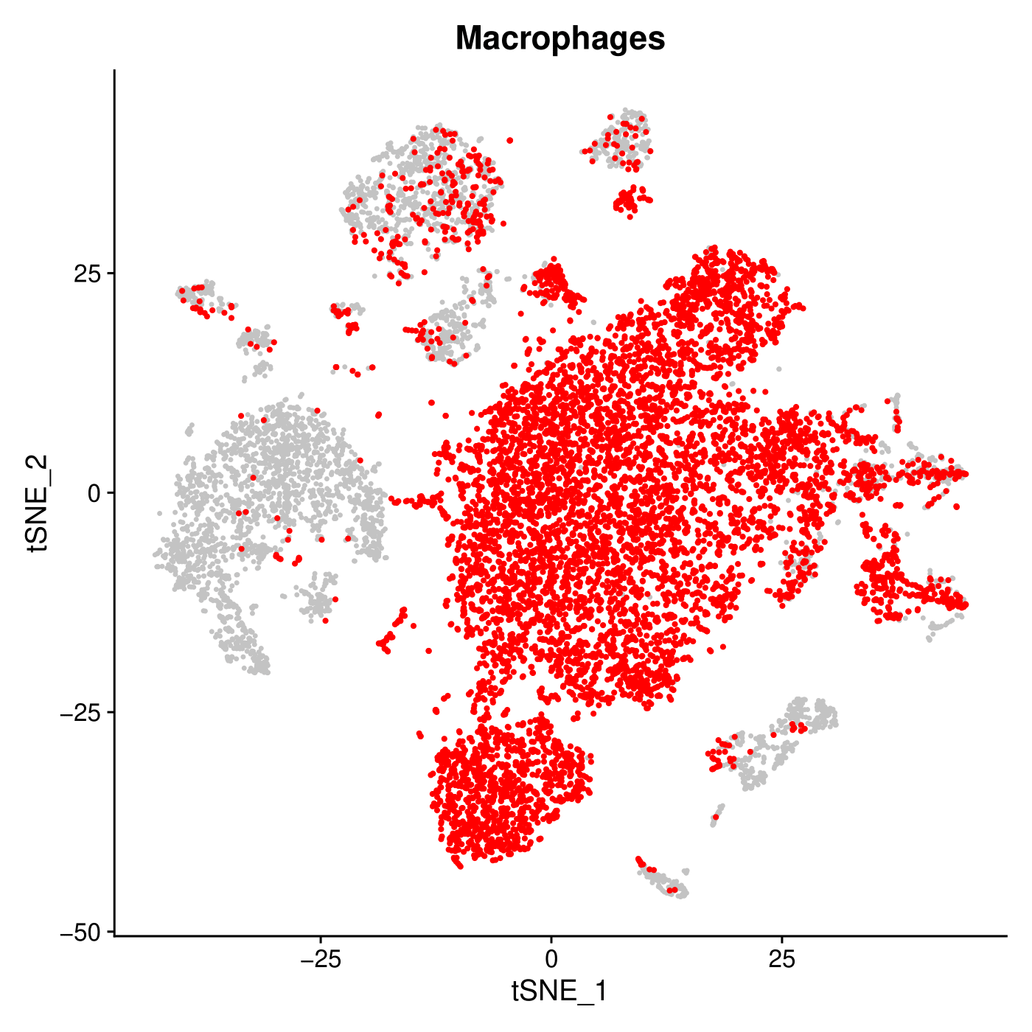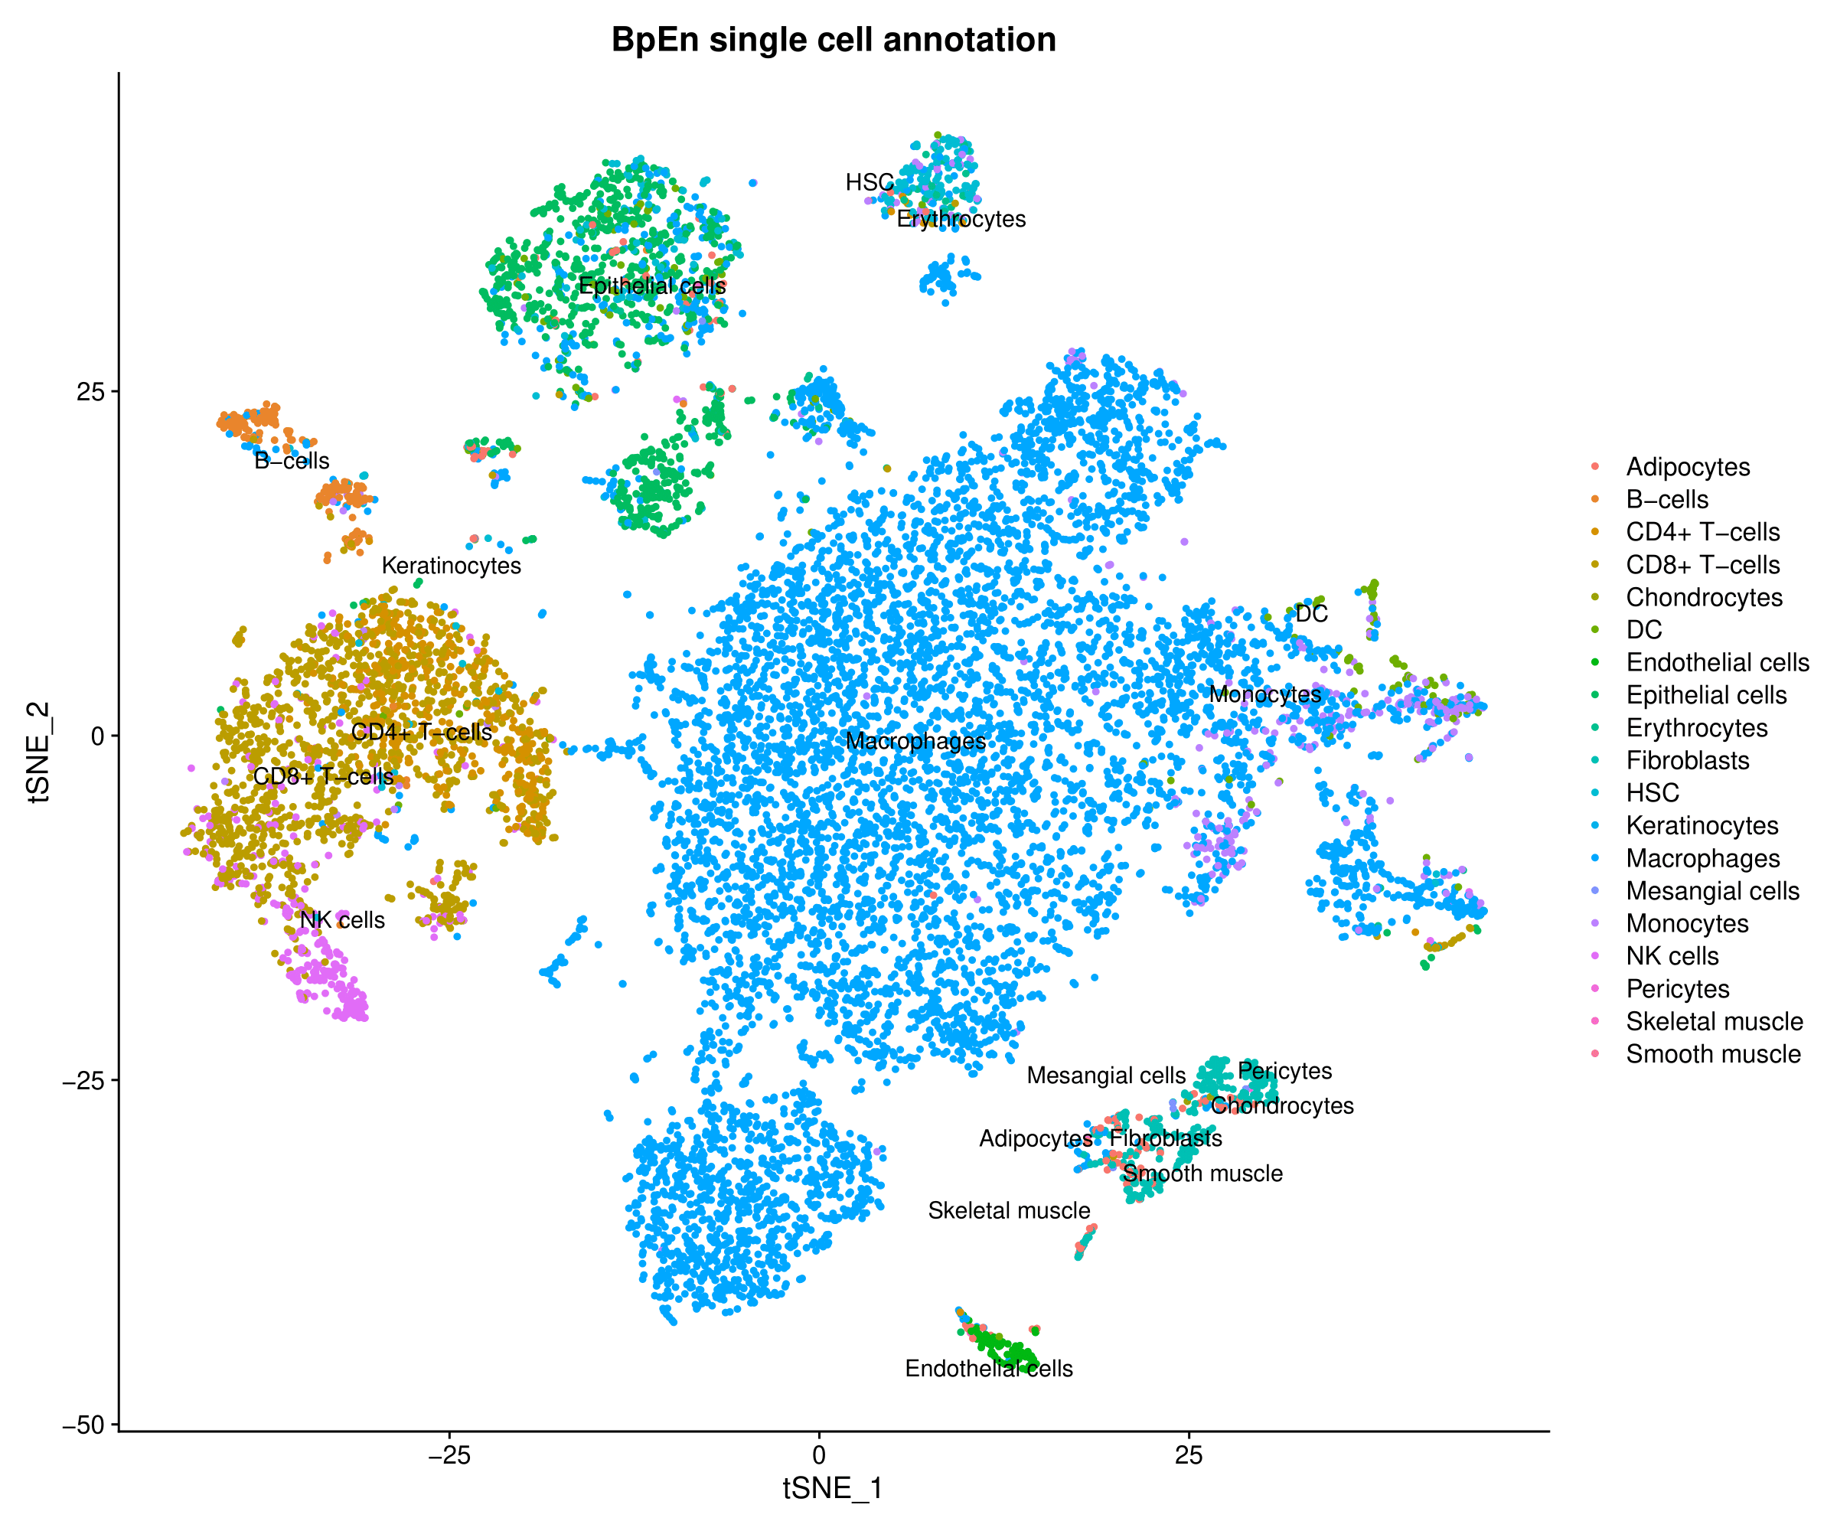

**Supplementary Figure 27.** UMAP cluster annotation graph generated by PoPsicle in the MakeAnnotation function. Annotation UMAP is reported (top); on the same embeddings, cells are coloured in red by their SingleR annotation (bottom). A dedicated plot is computed for each reference population. In this example, the reference is Blueprint Encode and the displayed population is the macrophages one. 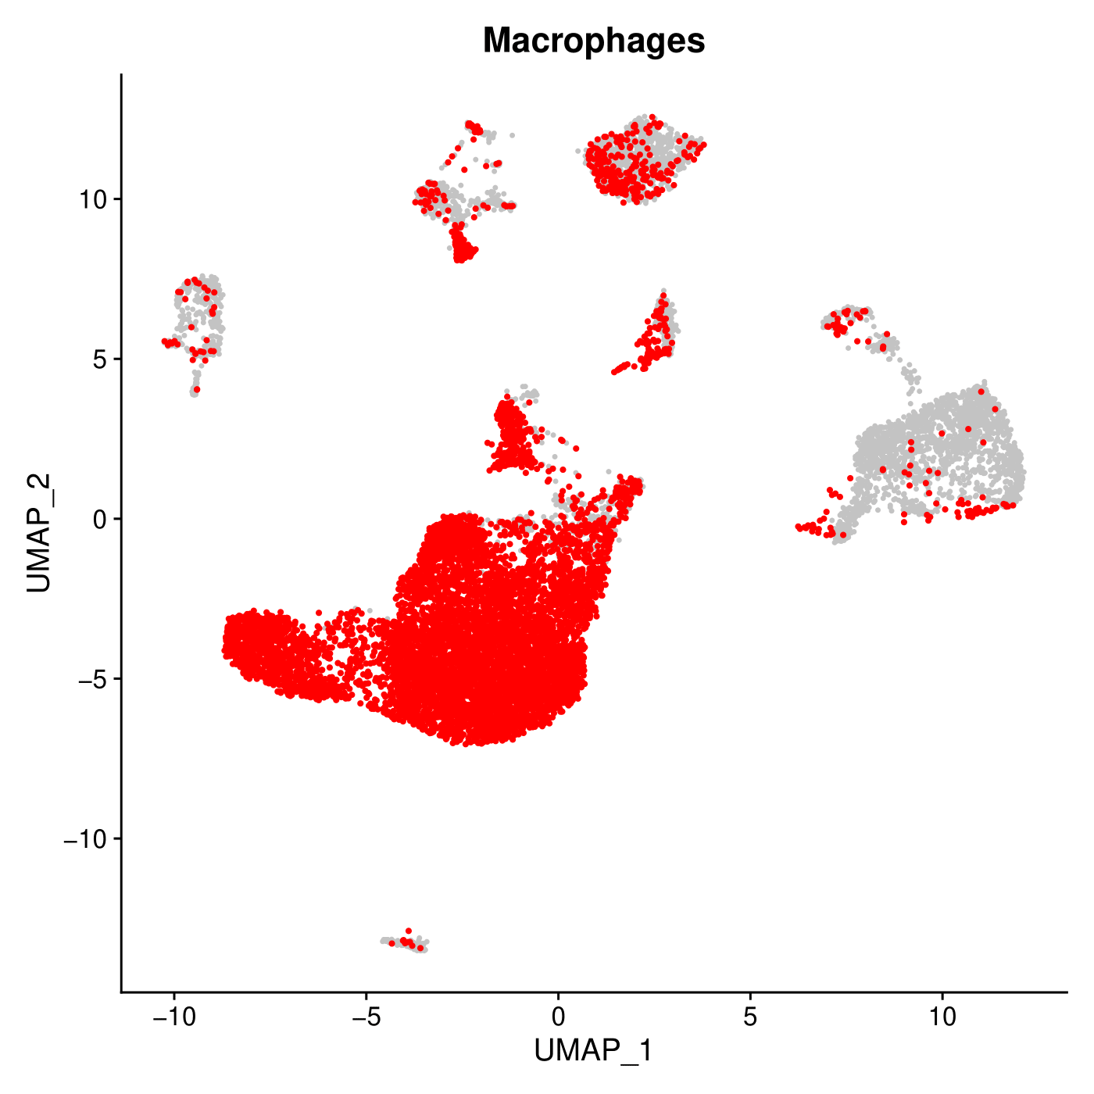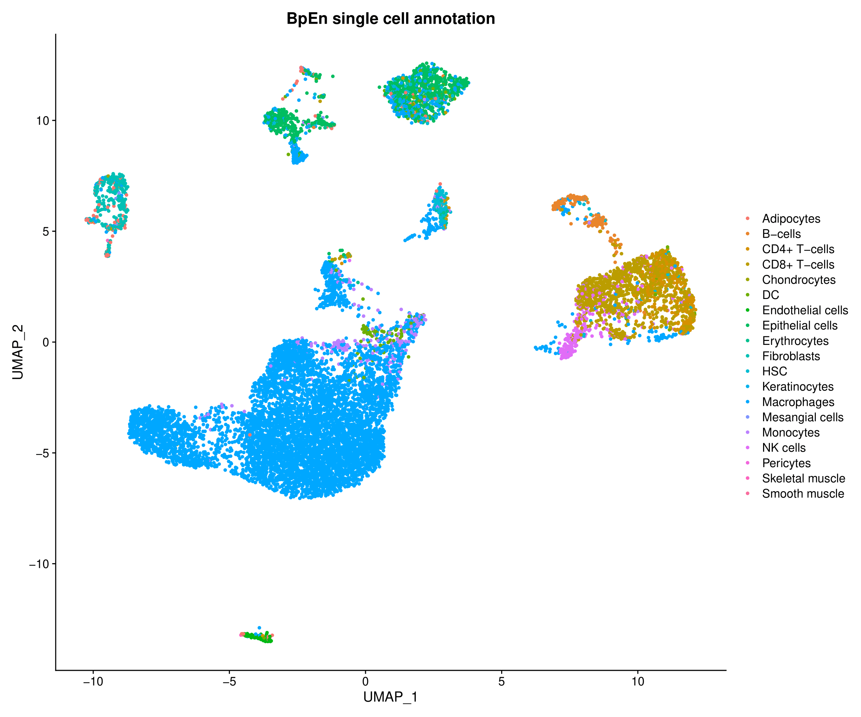

**Supplementary Figure 28.** Dotplot generated by PoPsicle in the MakeAnnotation function. This graph shows the correlation between the list of marker genes in PoPsicle (x axis), their associated labels (top), and the cellular populations annotated using SingleR (according to Blueprint Encode annotation). The plot highlights the concordance between the labels of the default immune marker list and the predicted population labels generated through annotation in SingleR.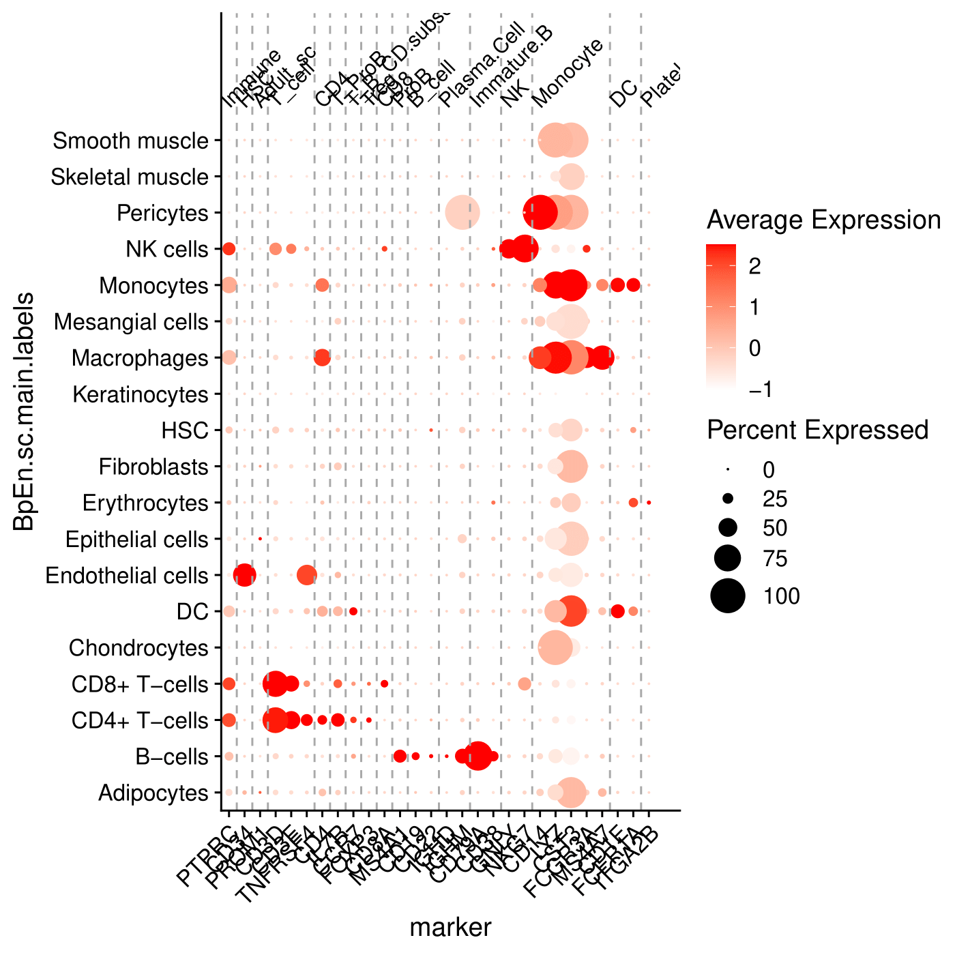

Here we report the default settings of MakeAnnotation as described in the dedicated vignette:

MakeAnnotation(UMI, organism, markers='none', thresh=20, out_folder=getwd())

Additional MakeAnnotation parameters are listed and discussed below:

UMI input Seurat object   
organism defines the organism for the annotation. “human” or “mouse” can be selected  
markers defines marker genes used for the plots, they must be the same used in CalculateCluster. By default, PoPsicle uses his own Immune markers lists.  
thresh this parameter sets the threshold for populations that are considered rare. The default upper limit is 20 cells. Populations with a number of cells lower than the set threshold value will be joined in a common group defined as “other”.  
out_folder defines the output folder in which results will be saved. Default is the current working directory, creating a subfolder named “05.Annotation”.

**INSTALLATION AND USAGE**

**Installation**

PoPsicle can be downloaded from **Github/bicciatolab**, and also can be installed via devtools. Moreover, a yaml file is available in the repository, granting the possibility to generate a fully functional environment using the Anaconda platform to run and test the package. PoPsicle builds on Seurat and some of the most common R modules for scRNA-seq analysis, listed in the **Dependencies** section of this Supplementary Materials. PoPsicle requires R version 3.6.3 or superior to be run accordingly.

**Dependencies**

PoPsicle builds on several different modules, which are mandatory for the correct installation and usage of the software. Here we will list all the required modules for PoPsicle:*Seurat, reticulate, R.utils, dplyr, ggplot2, SingleR, future, session, grid, gridExtra, magrittr, limma, patchwork, crayon, ggExtra, scMCA, RColorBrewer, RANN, neldermead, umap.*

Most of these modules can be installed via install.packages()in R, by calling the appropriate module (i.e.  install.packages(“ggplot2”) will extract the “ggplot2” package from the CRAN repositories and install it in your environment), while others may require dedicated installation procedures.

**Comparison with scCancer**

We compare our method with scCancer tool, a package to process and analyze droplet-based scRNA-seq data, particularly focused for cancer research (Wenbo Guo et al., a package for automated processing of single-cell RNA-seq data in cancer, Briefings in Bioinformatics, bbaa127, <https://doi.org/10.1093/bib/bbaa127>). We performed benchmark analysis on the same datasets using same parameters, than we compared results from

**REFERENCES**